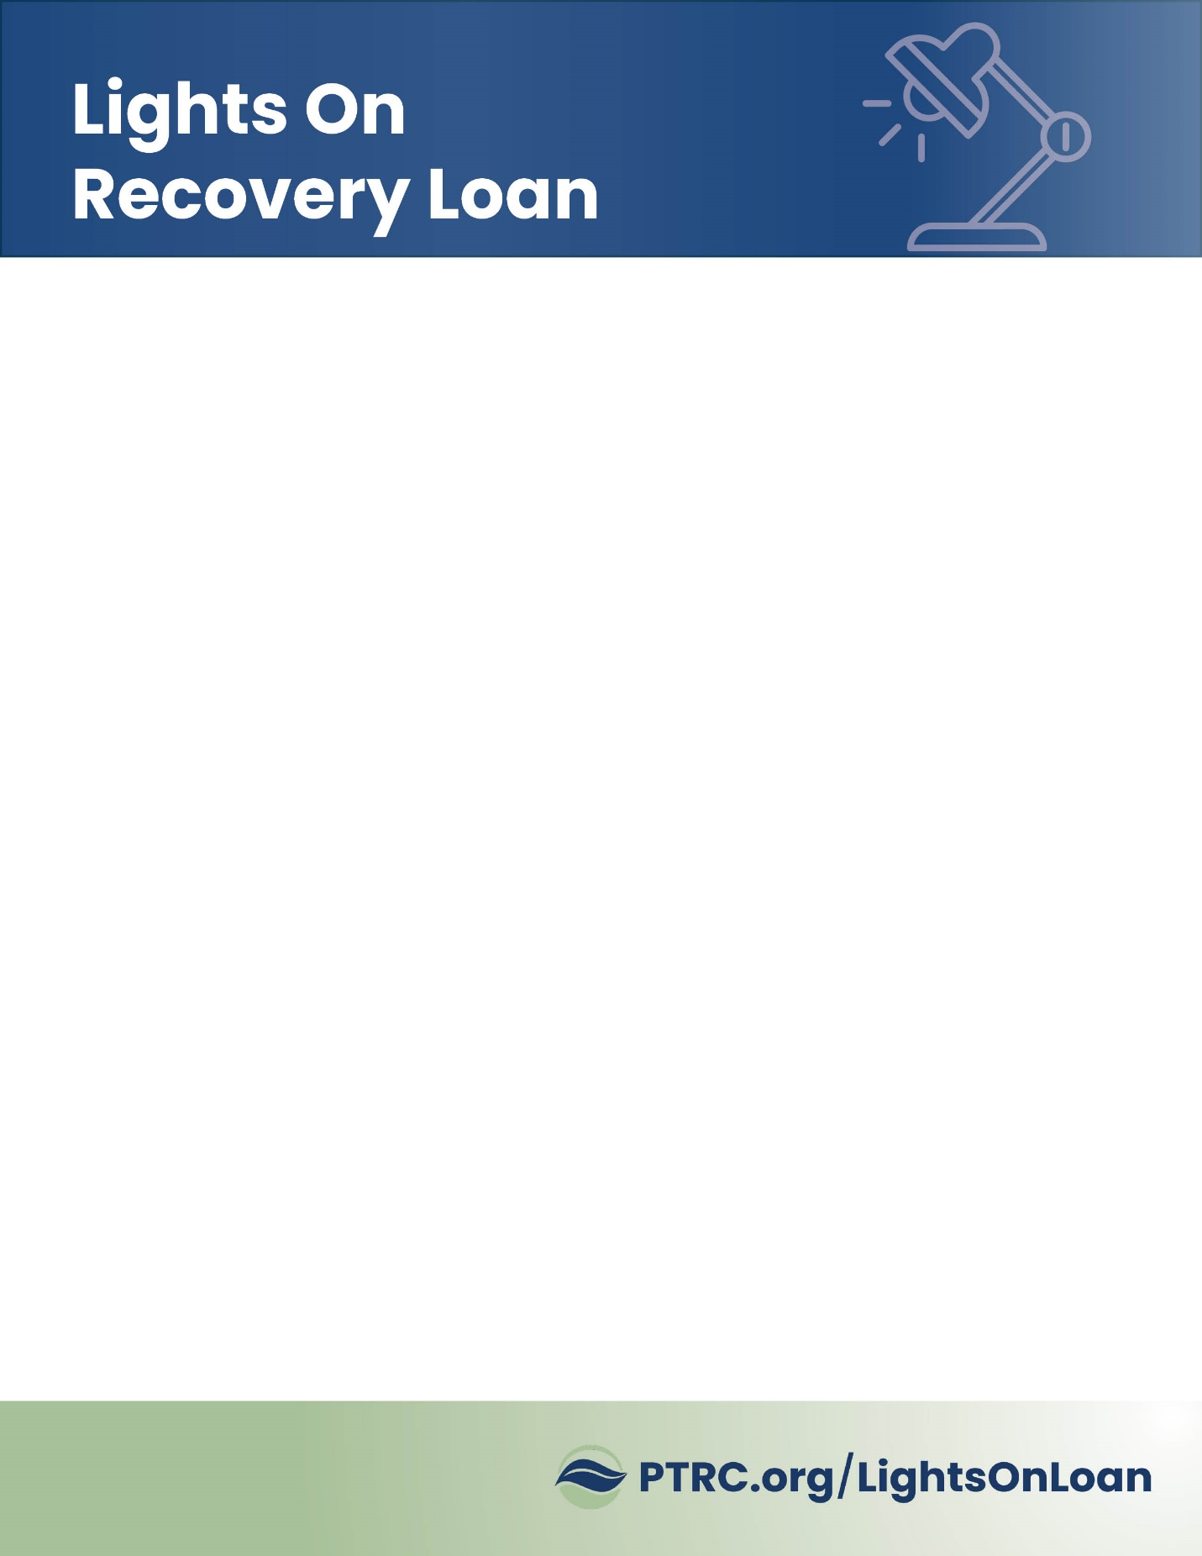

PTRC

COVID-19 Lights On Loan Program

Social Posts LINKEDIN

August 10, 2020

----------------------

LinkedIn Post 1

 **Piedmont Triad Regional Council**

Here’s help for Triad small businesses hurt by the pandemic. Our

Covid recovery loan program provides interest-free, 5-year loans to

cover payroll, rent, utilities and more. **Apply now to borrow up to $50,000 with a Lights On Covid Recovery Loan.**

www.PTRC.org/LightsOnLoan

#lightsonloan #economicdevelopment #nctriad #covid19 #smallbusiness



LinkedIn Post 2

 **Piedmont Triad Regional Council**

If your small business is suffering from the impact of COVID-19, you

may qualify for an interest-free, Lights On Recovery Loan. We have

$2 million to distribute here in the Triad. **Apply now to borrow up to $50,000 with a Lights On Covid Recovery Loan.**

www.PTRC.org/LightsOnLoan

#lightsonloan #economicdevelopment #nctriad #covid19 #smallbusiness



LinkedIn Post 3

 **Piedmont Triad Regional Council**

Struggling with the impact of Covid-19? Need capital to survive and thrive?

We offer interest-free loans, with emphasis on downtown and agricultural

small businesses. **Apply now to borrow up to $50,000 with a Lights On Covid Recovery Loan.**

www.PTRC.org/LightsOnLoan

#lightsonloan #economicdevelopment #nctriad #covid19 #smallbusiness

