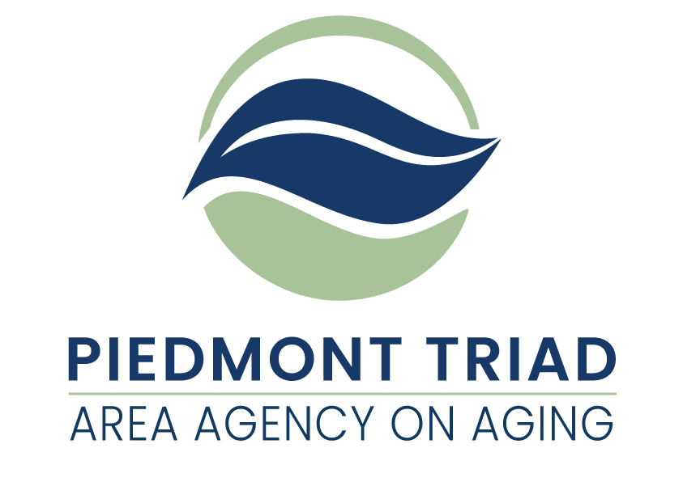

**American Rescue Plan Act**

**Family Caregiver Support Program**

**NC Caregivers - Trualta Platform Promotion Mini Grants Available**

This Request for Application (RFA) is for grant proposals funded by the American Rescue Plan Act of 2021 (ARPA). ARPA funds provide a unique opportunity to consider needs and service delivery that have the potential to respond to unmet needs of older adults and family caregivers. The Piedmont Triad Regional Council Area Agency on Aging (PTRC AAA) is taking a regional approach in distributing these funds based on the priorities established by the North Carolina Division of Aging and Adult Services.  Service match is not required, and funds will remain available until expended or until September 30, 2024, whichever comes first.

The project period for this funding is May 1, 2022 through September 30, 2024. All ARPA funds must be obligated by September 30, 2024.

Additional information is available on the PTRC website under the specific Family Caregiver Support Services links at <http://www.ptrc.org/Services/pandemic-recovery-funding-opportunities>.

**PTRC AAA is making five (5) mini grants for NC Caregivers – Trualta Platform Promotion of $6,000 each**

The goals of the FCSP are for caregivers to: be empowered through education; be informed of services available to them that can support their own well-being; and be connected to a support system that can help reduce their level of stress, social isolation, and caregiver burden.

The NC Division of Aging & Adult Services has partnered with Trualta to offer an easy-to-use, personalized, and evidence based on-demand learning platform for family caregivers across North Carolina. North Carolina caregivers may access the platform portal at the [Home - North Carolina (Trualta) (nc-caregivers.com)](https://nc-caregivers.com/home).

**Family Caregiver Support Program NC Caregivers – Trualta Platform Promotion Mini Grants**

Awarded grantees will advance the visibility and use of the platform portal within the Region to both family caregivers and Family Caregiver Support Program (FCSP) providers with the objectives of increasing the number of family caregivers accessing the platform portal. In addition, they will increase FCSP providers’ appreciation of the benefits it offers the family caregivers they encounter in their work, and its ability to increase their capacity to share vital caregiver information.

**Types of Services Included in this Mini Grant**

Information - A service for caregivers that provides the public and individuals with information on resources and services available to the individuals within their communities. This mini grant will focus on providing information about the NC Caregivers – Trualta Platform that will encourage caregivers to register and regularly access the portal for information and support.

Examples of activities aimed at promoting the NC Caregivers Trualta Platform include:

Community and program advocacy, outreach, assessment, planning, documentation, evaluation and oversight; organization and/or participation in community events (ex: job fairs, health fairs, senior center fairs); program promotion (ex: public service announcements); public information (ex: printing of publications and program brochures)

Administrative Functions: community and program advocacy, outreach, assessment, planning, documentation, oversight, developing public information: organization and/or participation in community events; program promotion

**Cost Computation Requirements**

An accurately completed FCSP Budget Form will be required of all ARPA Family Caregiver NC Caregivers – Trualta Platform Promotion award recipients.

**Reimbursement for Family Caregiver Support Program**

**ARPA Family Caregiver Support Program reimbursements are handled through a reimbursement system.** Services provided will be reimbursed on a monthly basis through the state’s Aging Resource Management System (ARMS). Reimbursement is dependent upon accurate reporting of services data.

**Monitoring**

All services provided by ARPA Family Caregiver Support Program will be monitored by the PTRC Area Agency on Aging (PTRC AAA) according to a timeline established by the North Carolina Division of Aging and Adult Services. Monitoring will be conducted following the “PTRC AAA Policies and Procedures for Monitoring” (November 2016) which also addresses the required monitoring of any subcontractors used to furnish services.

**Confidentiality and Security**

Client information in any format and whether recorded or not shall be kept confidential and not disclosed in a form that identifies the person without the informed consent of the person or legal representative. Community Services providers, including subcontractors and vendors, must adhere to all applicable federal, state, and departmental requirements for protecting the security and confidentiality of client information including, but not limited to appropriately restricting access, establishing procedures to reduce the risk of accidental disclosures from data processing systems, and developing a process by which the North Carolina Division of Aging and Adult Services is notified of suspected or confirmed security incidents and data breaches.

**Record Retention and Disposition**

All community Services providers are responsible for maintaining custody of records and documentation to support the allowable expenditure of funds, Services provision, and the reimbursement of services. Service providers must adhere to the approved record retention and disposition schedule posted semiannually on the website of the NC Department of Health and Human Services (DHHS) Controller at:

<https://www.ncdhhs.gov/about/administrative-offices/office-controller/records-retention>

Service providers are not authorized to destroy records related to the provision of Services under this Agreement except in compliance with the approved DHHS retention and disposition schedule, which allows for the proper destruction of records based on a schedule by funding source and fiscal year. Confidential records will be destroyed in such a manner that the records cannot be practically read or reconstructed.

**Project Period**

The Project Period for ARPA Family Caregiver NC Caregivers – Trualta Platform Promotion funds is May 1, 2022 through September 30, 2024.

**PTRC AAA reserves the right to reject any or all applications, waive technicalities, and to be the sole judge of suitability of the Services for their intended use, and further specifically reserves the right to make the award in the best interest of the PTRC AAA regional program.**

**Submitting an Application for** **ARPA Family Caregiver Support NC Caregivers – Trualta Platform Promotion**

**Three copies of the Request for Application (RFA) with original signatures** must be submitted to PTRC AAA, 1398 Carrollton Crossing Drive, Kernersville NC 27284 - Attention Gwen Shields by April 1, 2022, at 4:00 pm. Applications received after this date and time will not be considered for funding.

Proposals that best meet PTRC Area Agency on Aging (AAA) expectations for service delivery will be selected.

Applications will be scored based on their completeness and their description of intent to provide services.

All questions regarding the RFA must be submitted in writing by March 23, 2022, at 4:00 pm, to gshields@ptrc.org. After such time, and until projects are awarded, Applicants are prohibited from contacting PTRC AAA staff regarding any issue relating to these funds or the application process.

**PTRC AAA reserves the right to reject any or all applications, waive technicalities, and to be the sole judge of suitability of the services for their intended use, and further specifically reserves the right to make the award in the best interest of the PTRC AAA regional program.**

Failure to respond to any requirements outlined in the RFA, or failure to enclose completed copies of the required documents, may disqualify the application.

|  |  |
| --- | --- |
| **Timeline** | **Date/Time** |
| Announcement of Funding Availability | March 14, 2022 |
| Information Session* Prerecorded | Click on the link below |
| Final day to submit questions | March 23, 2022 |
| Applications Due | April 1, 2022 |
| Award Announcement | Week of April 25 |

*This is the link to the prerecorded Information Session:

<https://youtu.be/UCL3bRMVBvM>

**Upon award of the grant, an official budget will be completed and submitted using the required ARPA FCSP budget paperwork.**

**Evaluation Criteria**

PTRC AAA has developed a scoring tool to evaluate applications. The tool will be available on the PTRC website under the specific Family Caregiver Support Services links at [http://www.ptrc.org/Servicess/pandemic-recovery-funding-opportunities](http://www.ptrc.org/services/pandemic-recovery-funding-opportunities).

Proposals that best meet PTRC AAA expectations for services delivery will be selected. Applications will be scored based on their completeness and their description of intent to provide services. Priority consideration will be given to proposals that address the needs of older adults who are underserved, underrepresented, and/or part of a rural population or a food desert.

**Available Funding**

Use the following allocations to develop your funding request. Request must be reasonable, necessary, and justifiable.

**5 Mini Grants of up to $6,000 each**

All expenditures must be reasonable, necessary, and justifiable. All funds must be spent on activities related to the NC Caregivers - Trualta Platform Promotion. An organization may submit one application to provide promotion within multiple locations and/or counties.  Requested grant amounts cannot exceed $6,000.

**Monitoring**

All services provided by ARPA Family Caregiver Support Program funds will be monitored by the PTRC Area Agency on Aging (PTRC AAA) according to a timeline established by the North Carolina Division of Aging and Adult Services. Monitoring will be conducted following the “PTRC AAA Policies and Procedures for Monitoring” (November 2016) which also addresses the required monitoring of any subcontractors used to furnish services.

**NC Caregivers - Trualta Platform Promotion Mini Grants**

**Request for Application**

**Three copies of the Request for Applications (RFA) with original signatures** must be submitted to PTRC AAA, 1398 Carrollton Crossing Drive, Kernersville NC 27284 - Attention Gwen Shields by April 1, 2022, at 4:00 pm. Applications received after this date and time will not be considered for funding. Request must be reasonable, necessary, and justifiable.

**Project Contact Information**

Organization **(Full Legal Name Required)**:

Project Director: Title:

Mailing Address:

Phone Number: Email:

Board Chair (if applicable): Email:

Tax ID # **(required)**:

DUNS # **(Valid number required)**:

Type of agency:

Non-profit  For-profit  Government  Other  Specify _____________

**Required Information:** Submit one copy of your organization’s most recent financial statements (audited or unaudited). For those organizations submitting unaudited financial statements, a completed State Grant Certification and Sworn Statement and a completed Schedule of Receipts and Expenditures are also required. Additional information may be requested.

**Application Questions** *You many expand on the space provided. Word count is not limited.*

**Q1:** Tell us about your organization. What is your mission? What are you trying to accomplish overall? (This is likely more than can be achieved with a single grant.)

**Q2:** Describe what you are attempting to accomplish with this specific grant funding. How will you measure progress toward this goal?

**Q3:** Describe how older adults will be reached by this funding, especially in food deserts or rural areas.

**Q4:** What challenges do you anticipate and how will you address these issues? Challenges could include grant standards, the environment, limited transportation, etc.

**Q5:** Data shows that in North Carolina, African Americans, Latinos, American Indians and those living in poverty often suffer the worst health outcomes. We also know that the people most impacted by poor outcomes are not always included in creating solutions to these problems. Please describe how your work will address these disparities in outcomes and decision making on service delivery.

**NC Caregivers - Trualta Platform Promotion Mini Grants Request for Application Budget Proposal**

Use the following budget request to propose funding needs to support the services described above:

Provide a basic budget describing how the funds will support your services. Please be as specific as possible.

Examples: Staff member: 50 hours @ $25/hr. = $1,250; $2,000 newspaper advertising; $500 promotional community event.

**Upon award of the grant, an official budget will be completed using the required submit the required ARPA FCSP budget paperwork.**

Grant Amount Requested: County to Serve:

|  |  |
| --- | --- |
| Expense Categories | Budget |
| Personnel (itemize below) |  |
| Travel Cost (itemize below) |  |
| Meals Cost (itemize below) |  |
| Equipment (itemize below) |  |
| Personal Protective Equipment (itemize below) |  |
| Other (itemize below) |  |
| **TOTAL EXPENSES** |  |

|  |  |
| --- | --- |
| Itemized Categories | Budget |
| Personnel by Name & Position:  TOTAL |  |
| Travel to include but not limited to:  TOTAL |  |
| – Explain:  TOTAL |  |
| Equipment to include but not limited to:  TOTAL |  |
| Personal Protective Equipment to include but not limited to:  TOTAL |  |
| Other - itemize:  TOTAL |  |
| **TOTAL EXPENSES** |  |

**American Rescue Plan Act (ARPA) Bid Certification Statement**

**By signing and submitting its bid or proposal, the bidder or proposer certifies as follows:**

The certification in this clause is a material representation of fact relied upon by the AGENCY. If it is later determined by the AGENCY that the bidder or proposer knowingly rendered an erroneous certification, in addition to remedies available to the AGENCY, the Federal Government may pursue available remedies, including but not limited to suspension and/or debarment. The bidder or proposer agrees to comply with the requirements of 2 C.F.R. part 180, subpart C, as supplemented by 2 C.F.R. part 1200, while this offer is valid and throughout the period of any contract that may arise from this offer. The bidder or proposer further agrees to include a provision requiring such compliance in its lower tier covered transactions.

**Execution**

In compliance with this Request for Application (RFA) the undersigned Applicant offers and agrees to furnish and deliver any or all service proposed, at the budget proposed, and within the timeframe specified herein. By executing this Application, the undersigned Applicant confirms that it has read, understands and will comply with all specifications and requirements of this grant in the event of contract award.

PRINT NAME: ____________________________________________________________________

AUTHORIZED SIGNATURE: ___________________________________________________________

TITLE: _________________________________________________DATE: ______________________