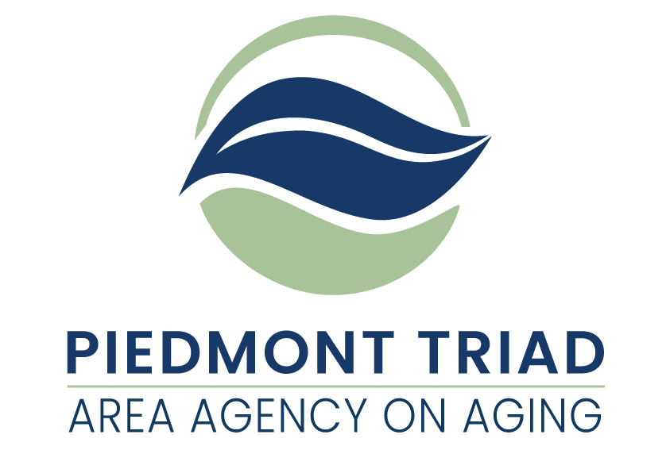

**American Rescue Plan Act**

Supportive Services Housing and Home Improvement Mini Grants Available

This Request for Application (RFA) is for grant proposals funded by the American Rescue Plan Act of 2021 (ARPA). ARPA funds provide a unique opportunity to consider needs and service delivery that have the potential to respond to unmet needs of older adults and family caregivers. The Piedmont Triad Regional Council Area Agency on Aging (PTRC AAA) is taking a regional approach in distributing these funds based on the priorities established by the North Carolina Division of Aging and Adult Services.  Service match is not required, and funds will remain available until expended or until September 30, 2024, whichever comes first.

The project period for this funding is November 1, 2022 through September 30, 2024. All ARPA funds must be obligated by September 30, 2024.

Additional information is available on the PTRC website under the specific Supportive Services links at <http://www.ptrc.org/services/pandemic-recovery-funding-opportunities>.

**PTRC AAA is making ARPA Supportive Services Housing and Home Improvement mini grants available to serve people 60 years of age or older who meet the eligibility requirements of Housing and Home Improvement as outlined in this Request for Application. Priority consideration will be given to proposals that address the needs of older adults who are underserved and/or underrepresented. Housing and Home Improvement providers awarded the grant funding must meet the program requirements as outlined in the NC Division of Aging and Adult Services Housing and Home Improvement Policies and Procedures (September 22, 2014).**

**ARPA Housing and Home Improvement Overview**

The Housing and Home Improvement service promotes independence and supports aging-in-place and aging-in-community to North Carolina’s seniors, families and persons with disabilities. The Housing and Home Improvement service identifies health and safety issues affecting the home or areas adjacent to the home and provides needed improvements or home modifications to enhance mobility and security.

**Eligibility Requirements for ARPA Housing and Home Improvement**

* People age 60+. Income is not used in determining eligibility.
* Have no one able and willing to perform the services for them.
* Reside within a county where the housing and home improvement service is funded.

**Program Guidance for ARPA Housing and Home Improvement**

**Housing:** Housing services support independent living by providing information to individuals and families to enable them to obtain housing, retain the housing they have or return to independent housing. Funded service providers have the option of providing this service.

**Home Improvement:** Home improvement services identify health and safety issues affecting the home or areas adjacent to the home in which an individual or family lives and provides needed improvements to resolve those issues. Health and safety issues include security enhancements; minor home repairs; mobility and accessibility improvements; and basic household furnishings and home appliance repair, replacement or purchase.

**Note:** Actual project costs – administrative, labor, and materials may not exceed $1,500 ($2,500 for ramps) per home per every twelve months of the project period. Actual project costs are costs incurred to provide an allowable service to an eligible client. The raising of the $1,500 cap per home per every twelve months of the project period is currently under review by the Federal Administration for Community Living.

Areas listed below constitute allowable Home Improvement expense items.

Security enhancements:

(a) door knobs installed with reliable lock and key and or dead lock bolts;

(b) windows fitted with reliable locks;

(c) emergency response systems installed (but not maintained);

(d) smoke detectors and carbon monoxide detectors installed (but not maintained) – provided this service is not provided by the local Fire Department.

Minor home repairs:

(a) repair to primary bathroom sink, shower/tub or commode;

(b) repair to kitchen sink;

(c) doorways widened;

(d) floor, wall, or ceiling repair;

(e) broken door or broken window repaired or replaced;

(f) shingles and roofing felt replaced.

Mobility and accessibility improvements:

(a) grab bar or handrail installation with solid blocking as needed;

(b) thresholds modified;

(c) steps repaired;

(d) ramps built and installed within or adjacent to the home.

Basic household furnishings and inoperable home appliances repair, replacement or purchase:

1. chair;
2. mattress/box springs;
3. stove;
4. hot water heater;
5. refrigerator;
6. washing machine;
7. heating or cooling unit.

**Note: Service providers may not exceed 20% of their entire ARPA Housing & Home Improvement allocation for the category “Basic household furnishings and inoperable home appliances repair, replacement or purchase” for the project period. Costs associated with repair, replacement or purchase of heating and air units should be excluded when determining if expenditures exceed the 20% limit.**

**Reporting and Documentation Requirements for ARPA Housing and Home Improvement**

* A Client Registration (DAAS 101) Long Form must be completed for each eligible participant receiving services through ARPA Housing and Home Improvement funding.
* A Client Intake, Needs Assessment, and Services must be completed in full by the service provider for each eligible participant.
* Consumer Contributions must be solicited twice and properly documented for each eligible participant receiving services through ARPA Housing and Home Improvement funding.
* A Client Financial and Service Activity Sheet must be completed in full by the service provider for each service rendered for each eligible participant.
* A Client Bill of Rights must be given to each eligible participant.
* Depending upon the circumstances of the eligible participant, additional forms, as specified by the NC Division of Aging and Adult Services, may be required.
* The funded service provider must have a signed and dated Service Provider Policies and Procedures form on file.

**Cost Computation Requirements for ARPA Housing and Home Improvement**

Accurately completed Cost Computation forms will be required of all ARPA Housing and Home Improvement grant awardees.

**Reimbursement for ARPA Housing and Home Improvement**

**ARPA Housing and Home Improvement reimbursements are handled through a reimbursement system.** Services provided will be reimbursed on a monthly basis through the state’s Aging Resource Management System (ARMS). Reimbursement is dependent upon accurate reporting of service data. **The service provider must request reimbursement for actual project costs: administration, labor, and materials, not to exceed $1,500 ($2,500 for ramps) per home per every twelve months of the project period. Actual project costs are costs incurred to provide an allowable service to a client.**

**Monitoring**

All services provided by ARPA Housing and Home Improvement funds will be monitored by the PTRC Area Agency on Aging (PTRC AAA) according to a timeline established by the North Carolina Division of Aging and Adult Services. Monitoring will be conducted following the “PTRC AAA Policies and Procedures for Monitoring” (November 2016).

**Confidentiality and Security**

Client information in any format and whether recorded or not shall be kept confidential and not disclosed in a form that identifies the person without the informed consent of the person or legal representative. Community service providers, including subcontractors and vendors, must adhere to all applicable federal, state, and departmental requirements for protecting the security and confidentiality of client information including, but not limited to appropriately restricting access, establishing procedures to reduce the risk of accidental disclosures from data processing systems, and developing a process by which the North Carolina Division of Aging and Adult Services is notified of suspected or confirmed security incidents and data breaches.

**Record Retention and Disposition**

All community service providers are responsible for maintaining custody of records and documentation to support the allowable expenditure of funds, service provision, and the reimbursement of services. Service providers must adhere to the approved record retention and disposition schedule posted semiannually on the website of the NC Department of Health and Human Services (DHHS) Controller at:

<https://www.ncdhhs.gov/about/administrative-offices/office-controller/records-retention>

Service providers are not authorized to destroy records related to the provision of services under this Agreement except in compliance with the approved DHHS retention and disposition schedule, which allows for the proper destruction of records based on a schedule by funding source and fiscal year. Confidential records will be destroyed in such a manner that the records cannot be practically read or reconstructed.

**Project Period**

The Project Period for ARPA Housing and Home Improvement funds is November 1, 2022 through September 30, 2024.

**PTRC AAA reserves the right to reject any or all applications, waive technicalities, and to be the sole judge of suitability of the services for their intended use, and further specifically reserves the right to make the award in the best interest of the PTRC AAA regional program.**

**Submitting an Application for** **ARPA Housing and Home Improvement**

**Three copies of the Request for Application (RFA) with original signatures** must be submitted to PTRC AAA, 1398 Carrollton Crossing Drive, Kernersville NC 27284 - Attention Gwen Shields by October 7, 2022, at 4:00 pm. Applications received after this date and time will not be considered for funding.

Proposals that best meet PTRC Area Agency on Aging (AAA) expectations for service delivery will be selected.

Applications will be scored based on their completeness and their description of intent to provide services.

All questions regarding the RFA must be submitted in writing by September 30, 2022, at 4:00 pm, to [gshields@ptrc.org](mailto:gshields@ptrc.org). After such time, and until projects are awarded, Applicants are prohibited from contacting PTRC AAA staff regarding any issue relating to these funds or the application process.

**PTRC AAA reserves the right to reject any or all applications, waive technicalities, and to be the sole judge of suitability of the services for their intended use, and further specifically reserves the right to make the award in the best interest of the PTRC AAA regional program.**

Failure to respond to any requirements outlined in the RFA, or failure to enclose completed copies of the required documents, may disqualify the application.

|  |  |
| --- | --- |
| **Timeline** | **Date/Time** |
| Announcement of Funding Availability | September 9, 2022 |
| Information Session* Prerecorded | Click on link below. |
| Final day to submit questions | September 30, 2022 at 4:00 pm |
| Applications Due | October 7, 2022 at 4:00 pm |
| Award Announcement | Early November 2022. |

*This is the link to the prerecorded Information Session:

<https://youtu.be/t-p5x64sr-c>

**Evaluation Criteria**

PTRC AAA has developed a scoring tool to evaluate applications. The tool will be available on the PTRC website at <http://www.ptrc.org/services/pandemic-recovery-funding-opportunities>.

Proposals that best meet PTRC AAA expectations for service delivery will be selected. Applications will be scored based on their completeness and their description of intent to provide services. Priority consideration will be given to proposals that address the needs of older adults who are underserved and/or, underrepresented.

**Available Funding**

Use the following allocations to develop your funding request. Request must be reasonable, necessary, and justifiable.

**5 mini grants of up to $75,000 each**

All expenditures must be reasonable, necessary, and justifiable. All funds must be spent on activities related to ARPA Housing and Home Improvement. An organization may submit multiple applications to provide ARPA Housing and Home Improvement services in multiple counties. Each application will be reviewed separately. Requested grant amounts cannot exceed $75,000.

**Monitoring**

All services provided by ARPA Housing and Home Improvement funds will be monitored by the PTRC Area Agency on Aging (PTRC AAA) according to a timeline established by the North Carolina Division of Aging and Adult Services. Monitoring will be conducted following the “PTRC AAA Policies and Procedures for Monitoring” (November 2016).

**This space intentionally left blank**

**ARPA Housing and Home Improvement**

**Request for Application**

**Three copies of the Request for Applications (RFA) with original signatures** must be submitted to PTRC AAA, 1398 Carrollton Crossing Drive, Kernersville NC 27284 - Attention Gwen Shields by October 7, 2022, at 4:00 pm. Applications received after this date and time will not be considered for funding. Request must be reasonable, necessary, and justifiable.

**Project Contact Information**

Organization **(Full Legal Name Required)**:

Project Director: Title:

Mailing Address:

Phone Number: Email:

Board Chair (if applicable): Email:

Tax ID # **(required)**:

SAMS Unique Entity ID (UEI) # **(Valid number required)**:

Type of agency:

Non-profit  For-profit  Government  Other  Specify _____________

**Required Information:** Submit one copy of your organization’s most recent financial statements (audited or unaudited). For those organizations submitting unaudited financial statements, a completed State Grant Certification and Sworn Statement and a completed Schedule of Receipts and Expenditures are also required. Additional information may be requested.

**Application Questions** *You many expand on the space provided. Word count is not limited.*

**Q1:** Tell us about your organization. What is your mission? What are you trying to accomplish overall? (This is likely more than can be achieved with a single grant.)

**Q2:** Describe what you are attempting to accomplish with this specific grant funding.

**Q3**: How will you measure progress toward this goal?

**Q4:** Describe how older adults will be reached by this funding, especially those who are underserved and/or underrepresented.

**Q5:** What challenges do you anticipate and how will you address these issues? Challenges could include grant standards, the environment, etc.

**Q6:** North Carolina data shows that African Americans, Latinos, American Indians and those living in poverty often suffer the worst health outcomes. We also know that the people most impacted by poor outcomes are not always included in creating solutions to these problems. Please describe how your work will address these disparities in outcomes and decision making on service delivery.

**Q7:** Please identify each of the four areas your agency intends to address with ARPA HHI funds. (Circle/Mark each)

Security Enhancements Minor Home Repairs Mobility and Accessibility Improvements

Basic Household Furnishings and Inoperable Home Appliance Repair, Replacement or Purchase **ARPA Housing and Home Improvement**

**Request for Application**

Use the following budget request to propose funding needs to support the services described above:

Provide a basic budget describing how the funds will support your service. Please be as specific as possible.

**Upon award of the grant, an official budget will be completed using the required Cost Computation forms.**

**Actual project costs – administrative, labor, and materials may not exceed $1,500 ($2,500 for ramps) per home per every twelve months of the project period. Actual project costs are costs incurred to provide an allowable service to an eligible client. The raising of the $1,500 cap per home per every twelve months of the project period is currently under review by the Federal Administration for Community Living.**

Grant Amount Requested: Location/County to Serve:

|  |  |
| --- | --- |
| Expense Categories | Budget |
| Administrative Costs |  |
| Cost of Labor for the Projects |  |
| Cost of Materials for the Projects |  |
| **TOTAL EXPENSES** |  |

|  |  |
| --- | --- |
| Itemized Categories | Budget |
| Administrative Costs, including administrative salary, itemize:  TOTAL |  |
| Cost of Labor for the Projects:  TOTAL |  |
| Cost of Materials for the Projects:  TOTAL |  |
| **TOTAL EXPENSES** |  |

**American Rescue Plan Act (ARPA) Bid Certification Statement**

**By signing and submitting its bid or proposal, the bidder or proposer certifies as follows:**

The certification in this clause is a material representation of fact relied upon by the AGENCY. If it is later determined by the AGENCY that the bidder or proposer knowingly rendered an erroneous certification, in addition to remedies available to the AGENCY, the Federal Government may pursue available remedies, including but not limited to suspension and/or debarment. The bidder or proposer agrees to comply with the requirements of 2 C.F.R. part 180, subpart C, as supplemented by 2 C.F.R. part 1200, while this offer is valid and throughout the period of any contract that may arise from this offer. The bidder or proposer further agrees to include a provision requiring such compliance in its lower tier covered transactions.

**Execution**

In compliance with this Request for Application (RFA) the undersigned Applicant offers and agrees to furnish and deliver any or all services proposed, at the budget proposed, and within the timeframe specified herein. By executing this Application, the undersigned Applicant confirms that it has read, understands and will comply with all specifications and requirements of this grant in the event of contract award.

PRINT NAME: ____________________________________________________________________

AUTHORIZED SIGNATURE: ___________________________________________________________

TITLE: _________________________________________________DATE: ______________________

**PTRC AAA reserves the right to reject any or all applications, waive technicalities, and to be the sole judge of suitability of the services for their intended use, and further specifically reserves the right to make the award in the best interest of the PTRC AAA regional program.**