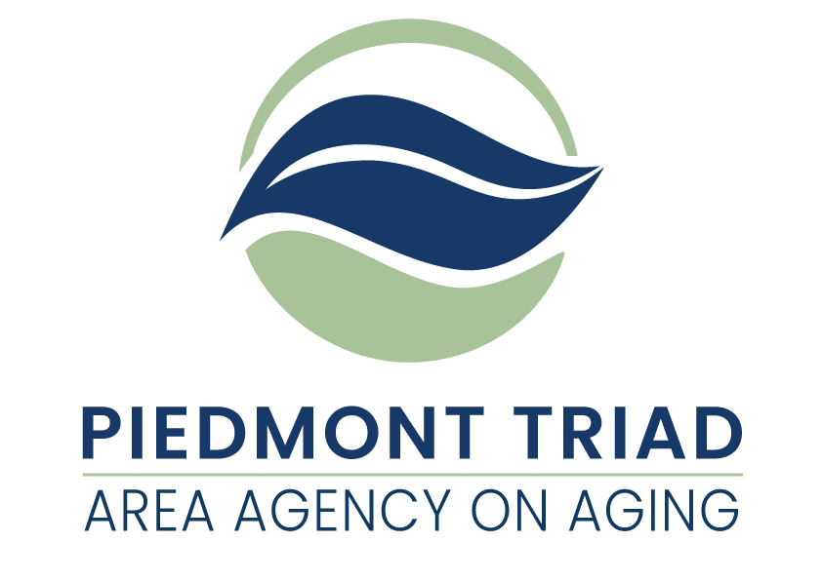

**American Rescue Plan Act**

Supportive Services Mental Health Counseling Mini Grants Available

This Request for Application (RFA) is for grant proposals funded by the American Rescue Plan Act of 2021 (ARPA). ARPA funds provide a unique opportunity to consider needs and service delivery that have the potential to respond to unmet needs of older adults and family caregivers. The Piedmont Triad Regional Council Area Agency on Aging (PTRC AAA) is taking a regional approach in distributing these funds based on the priorities established by the North Carolina Division of Aging and Adult Services.  Service match is not required, and funds will remain available until expended or until September 30, 2024, whichever comes first.

The project period for this funding is November 1, 2022 through September 30, 2024. All ARPA funds must be obligated by September 30, 2024.

Additional information is available on the PTRC website under:

<http://www.ptrc.org/services/pandemic-recovery-funding-opportunities>.

**PTRC AAA is making 4 ARPA Mental Health Counseling mini grants of $75,000 each available to serve people 60 years of age or older who meet the eligibility requirements of Mental Health Counseling as outlined in this Request for Application. Priority consideration will be given to proposals that address the needs of older adults who are underserved and/or underrepresented. Mental Health Counseling providers awarded the grant funding must meet the program requirements as outlined in the NC Division of Aging and Adult Services, Mental Health Counseling – Policies and Procedures (July 1, 2011).**

**ARPA Mental Health Counseling Overview**

Mental Health Counseling provides services which will enhance the ability of persons who may be experiencing mental health problems, including dementia, to meet their mental health treatment needs. This grant does allow for awardees to travel to the homes of clients to provide the services with an emphasis on older adults living independently in their communities.

**Eligibility Requirements for ARPA Mental Health Counseling**

* People age 60+ that are experiencing mental health problems. Income is not used in determining eligibility.
* A family caregiver of an eligible older adult that is experiencing mental health problems. Income is not used in determining eligibility.

**Program Guidance for ARPA Mental Health Counseling**

Allowable service tasks are as follows:

* Case Consultation – Consultation to a health care practitioner or local service provider regarding an eligible adult. This may include an assessment, evaluation, or consultation regarding the eligible person who is receiving services from the health care practitioner or provider.
* Evaluation – An appraisal to determine the nature of an individual’s mental health problem and his or her need for service. This may include an assessment of the nature and extent of the person’s problem through a systematic appraisal of the mental, psychological, physical, behavioral, functional, social, economic, and/or, intellectual resources of the individual for the purposes of diagnosis and determination of the most appropriate plan, if any, for services.
* Outpatient Treatment – Outpatient mental health treatment is designed to meet the treatment needs of an eligible adult. Treatment modalities may include counseling (individual or group), psychotherapy, medication therapy, and collateral work with family members. **Partial hospitalization and/or day hospitalization are not allowable services under this service.** Development of a written treatment plan is required within 30 days of accepting an eligible older adult for treatment. Plans should be updated every six months or sooner if clinically indicated.

**Staffing Requirements**

ARPA Mental Health Counseling services shall be provided by a “qualified professional” as defined in NC Administrative Code. There are four categories of “qualified professionals” with all “qualified professionals” having some accumulated Mental Health (MH) / Developmental Disabilities (DD) / Substance Abuse (SA) experience with the population served.

* An individual who holds a license, provisional license, certificate, registration or permit issued by the governing board regulating a human service profession, except a registered nurse who is licensed to practice in the State of North Carolina by the North Carolina Board of Nursing who also has four years of full-time accumulated experience in MH/DD/SA with the population served; or
* A graduate of a college or university with a master’s degree in a human service field and has one year of full-time, post-graduate degree accumulated MH/DD/SA experience with the population served, or a substance abuse professional who has one year of full-time, post-graduate degree accumulated supervised experience in alcoholism and drug abuse counseling; or
* A graduate of a college or university with a bachelor’s degree in a human service field and has two years of full-time, post-bachelor’s degree accumulated MH/DD/SA experience with the population served, or a substance abuse professional who has two years of full-time, post-bachelor’s degree accumulated supervised experience in alcoholism and drug abuse counseling; or
* A graduate of a college or university with a bachelor’s degree in a field other than human services and has four years of full-time, post-bachelor’s degree accumulated MH/DD/SA experience with the population served, or a substance abuse professional who has four years of full-time, post-bachelor’s degree accumulated supervised experience in alcoholism and drug abuse counseling.

**Reporting and Documentation Requirements for ARPA Mental Health Counseling**

* A Client Registration (DAAS 101) Form must be completed for each eligible participant receiving services (case consultation, evaluation, and outpatient treatment) through ARPA Mental Health Counseling funding. In order to maintain accurate client data, agencies must conduct an update of the Client Registration (DAAS 101) Form for those persons receiving outpatient treatment services every twelve months.
* Consumer Contributions must be solicited and properly documented for each eligible participant receiving services through ARPA Mental Health Counseling funding.
* Agencies providing ARPA Mental Health Counseling will maintain, at a minimum, a log of case consultation and evaluation services provided. This log shall include at a minimum, the following information:
* Client’s name
* Client’s date of birth
* Identify how client meets eligibility requirements
* Type of service client received (case consultation; evaluation)
* Date(s) of service
* Indication that the date(s) of service on invoice match date(s) of service on log.
* Agencies providing ARPA Mental Health Counseling will maintain a client record on all persons receiving outpatient treatment services.

**Cost Computation Requirements for ARPA Mental Health Counseling**

Accurately completed Cost Computation forms will be required of all ARPA Mental Health Counseling grant awardees.

**Reimbursement for ARPA Mental Health Counseling**

**ARPA Mental Health Counseling reimbursements are handled through a reimbursement system.** Services provided will be reimbursed on a monthly basis through the state’s Aging Resource Management System (ARMS). Reimbursement is dependent upon accurate reporting of service data.

**Monitoring**

All services provided by ARPA Mental Health Counseling funds will be monitored by the PTRC Area Agency on Aging (PTRC AAA) according to a timeline established by the North Carolina Division of Aging and Adult Services. Monitoring will be conducted following the “PTRC AAA Policies and Procedures for Monitoring” (November 2016) which also addresses the required monitoring of any subcontractors used to furnish services.

**Confidentiality and Security**

Client information in any format and whether recorded or not shall be kept confidential and not disclosed in a form that identifies the person without the informed consent of the person or legal representative. Community service providers, including subcontractors and vendors, must adhere to all applicable federal, state, and departmental requirements for protecting the security and confidentiality of client information including, but not limited to appropriately restricting access, establishing procedures to reduce the risk of accidental disclosures from data processing systems, and developing a process by which the North Carolina Division of Aging and Adult Services is notified of suspected or confirmed security incidents and data breaches.

**Record Retention and Disposition**

All community service providers are responsible for maintaining custody of records and documentation to support the allowable expenditure of funds, service provision, and the reimbursement of services. Service providers must adhere to the approved record retention and disposition schedule posted semiannually on the website of the NC Department of Health and Human Services (DHHS) Controller at:

<https://www.ncdhhs.gov/about/administrative-offices/office-controller/records-retention>

Service providers are not authorized to destroy records related to the provision of services under this Agreement except in compliance with the approved DHHS retention and disposition schedule, which allows for the proper destruction of records based on a schedule by funding source and fiscal year. Confidential records will be destroyed in such a manner that the records cannot be practically read or reconstructed.

**Project Period**

The Project Period for ARPA Mental Health Counseling funds is November 1, 2022 through September 30, 2024.

**PTRC AAA reserves the right to reject any or all applications, waive technicalities, and to be the sole judge of suitability of the services for their intended use, and further specifically reserves the right to make the award in the best interest of the PTRC AAA regional program.**

**Submitting an Application for** **ARPA Mental Health Counseling**

**Three copies of the Request for Application (RFA) with original signatures** must be submitted to PTRC AAA, 1398 Carrollton Crossing Drive, Kernersville NC 27284 - Attention Gwen Shields by October 14, 2022, at 4:00 pm. Applications received after this date and time will not be considered for funding.

Proposals that best meet PTRC Area Agency on Aging (AAA) expectations for service delivery will be selected.

Applications will be scored based on their completeness and their description of intent to provide services.

All questions regarding the RFA must be submitted in writing by October 7, 2022, at 4:00 pm, to gshields@ptrc.org. After such time, and until projects are awarded, Applicants are prohibited from contacting PTRC AAA staff regarding any issue relating to these funds or the application process.

**PTRC AAA reserves the right to reject any or all applications, waive technicalities, and to be the sole judge of suitability of the services for their intended use, and further specifically reserves the right to make the award in the best interest of the PTRC AAA regional program.**

Failure to respond to any requirements outlined in the RFA, or failure to enclose completed copies of the required documents, may disqualify the application.

|  |  |
| --- | --- |
| **Timeline** | **Date/Time** |
| Announcement of Funding Availability | September 23, 2022 |
| Information Session* Prerecorded | Click on link below. |
| Final day to submit questions | October 7, 2022 at 4 pm |
| Applications Due | October 14, 2022 at 4 pm |
| Award Announcement | Early November 2022. |

*This is the link to the prerecorded Information Session:

(insert link here)

**Evaluation Criteria**

PTRC AAA has developed a scoring tool to evaluate applications. The tool will be available on the PTRC website.

Proposals that best meet PTRC AAA expectations for service delivery will be selected. Applications will be scored based on their completeness and their description of intent to provide services. Priority consideration will be given to proposals that address the needs of older adults who are underserved and/or, underrepresented.

**Available Funding**

Use the following allocations to develop your funding request. Request must be reasonable, necessary, and justifiable.

**4 mini grants of up to $75,000 each**

All expenditures must be reasonable, necessary, and justifiable. All funds must be spent on activities related to ARPA Mental Health Counseling. An organization may submit multiple applications to provide ARPA Mental Health Counseling services in multiple counties. Each application will be reviewed separately. Requested grant amounts cannot exceed $75,000.

**Monitoring**

All services provided by ARPA Mental Health Counseling funds will be monitored by the PTRC Area Agency on Aging (PTRC AAA) according to a timeline established by the North Carolina Division of Aging and Adult Services. Monitoring will be conducted following the “PTRC AAA Policies and Procedures for Monitoring” (November 2016) which also addresses the required monitoring of any subcontractors used to furnish services.

**ARPA Mental Health Counseling**

**Request for Application**

**Three copies of the Request for Applications (RFA) with original signatures** must be submitted to PTRC AAA, 1398 Carrollton Crossing Drive, Kernersville NC 27284 - Attention Gwen Shields by October 14, 2022, at 4:00 pm. Applications received after this date and time will not be considered for funding. Request must be reasonable, necessary, and justifiable.

**Project Contact Information**

Organization **(Full Legal Name Required)**:

Project Director: Title:

Mailing Address:

Phone Number: Email:

Board Chair (if applicable): Email:

Tax ID # **(required)**:

SAMS Unique Entity ID (UEI) # **(Valid number required)**:

Type of agency:

Non-profit  For-profit  Government  Other  Specify _____________

**Required Information:** Submit one copy of your organization’s most recent financial statements (audited or unaudited). For those organizations submitting unaudited financial statements, a completed State Grant Certification and Sworn Statement and a completed Schedule of Receipts and Expenditures are also required. Additional information may be requested.

**Application Questions** *You many expand on the space provided. Word count is not limited.*

**Q1:** Tell us about your organization. What is your mission? What are you trying to accomplish overall? (This is likely more than can be achieved with a single grant.)

**Q2:** Describe what you are attempting to accomplish with this specific grant funding.

**Q3:** How will you measure progress toward this goal?

**Q4:** Describe how older adults will be reached by this funding, especially those who are underserved and/or underrepresented.

**Q5:** What challenges do you anticipate and how will you address these issues? Challenges could include grant standards, the environment, etc.

**Q6:** Data shows that in North Carolina, African Americans, Latinos, American Indians and those living in poverty often suffer the worst health outcomes. We also know that the people most impacted by poor outcomes are not always included in creating solutions to these problems. Please describe how your work will address these disparities in outcomes and decision making on service delivery.

**Request for Application**

Use the following budget request to propose funding needs to support the services described above:

Provide a basic budget describing how the funds will support your service. Please be as specific as possible.

**Upon award of the grant, an official budget will be completed using the required Cost Computation forms.**

**No more than 5% of the total of each ARPA Mental Health Counseling grant will be allowed for Personal Protective Equipment and other consumable supplies.**

Grant Amount Requested: Location/County to Serve:

|  |  |
| --- | --- |
| **Expense Categories** | **Budget** |
| Administrative Costs (itemize below) |  |
| Cost of Mental Health Counseling Services |  |
| PPE & Other Consumable Supplies (itemize below) |  |
| **TOTAL EXPENSES** |  |

|  |  |
| --- | --- |
| Itemized Categories | Budget |
| Administrative Costs, including administrative salary (itemize by Name & Position):  TOTAL |  |
| Cost of Mental Health Counseling Services:  TOTAL |  |
| PPE & Other Consumable Supplies (itemize):  TOTAL |  |
| **TOTAL EXPENSES** |  |

**American Rescue Plan Act (ARPA) Bid Certification Statement**

**By signing and submitting its bid or proposal, the bidder or proposer certifies as follows:**

The certification in this clause is a material representation of fact relied upon by the AGENCY. If it is later determined by the AGENCY that the bidder or proposer knowingly rendered an erroneous certification, in addition to remedies available to the AGENCY, the Federal Government may pursue available remedies, including but not limited to suspension and/or debarment. The bidder or proposer agrees to comply with the requirements of 2 C.F.R. part 180, subpart C, as supplemented by 2 C.F.R. part 1200, while this offer is valid and throughout the period of any contract that may arise from this offer. The bidder or proposer further agrees to include a provision requiring such compliance in its lower tier covered transactions.

**Execution**

In compliance with this Request for Application (RFA) the undersigned Applicant offers and agrees to furnish and deliver any or all services proposed, at the budget proposed, and within the timeframe specified herein. By executing this Application, the undersigned Applicant confirms that it has read, understands and will comply with all specifications and requirements of this grant in the event of contract award.

PRINT NAME: ____________________________________________________________________

AUTHORIZED SIGNATURE: ___________________________________________________________

TITLE: _________________________________________________DATE: ______________________

**PTRC AAA reserves the right to reject any or all applications, waive technicalities, and to be the sole judge of suitability of the services for their intended use, and further specifically reserves the right to make the award in the best interest of the PTRC AAA regional program.**