**ARMS Instruction: How to Create a Production NCID Account**

**NOTE:** If you already have a NCID, you only need to provide your NCID username and email address tired to that NCID account to Susan Ferriola [sferriola@ptrc.org](mailto:sferriola@ptrc.org), Gwen Shields [gshields@ptrc.org](mailto:gshields@ptrc.org) or Laura Quiceno [lquiceno@ptrc.org](mailto:lquiceno@ptrc.org)

If you **do not** have a NCID account, please continue to read the directions below for setting up a NCID account.

1). To obtain a NCID account, open your web browser and type: <https://ncid.nc.gov>

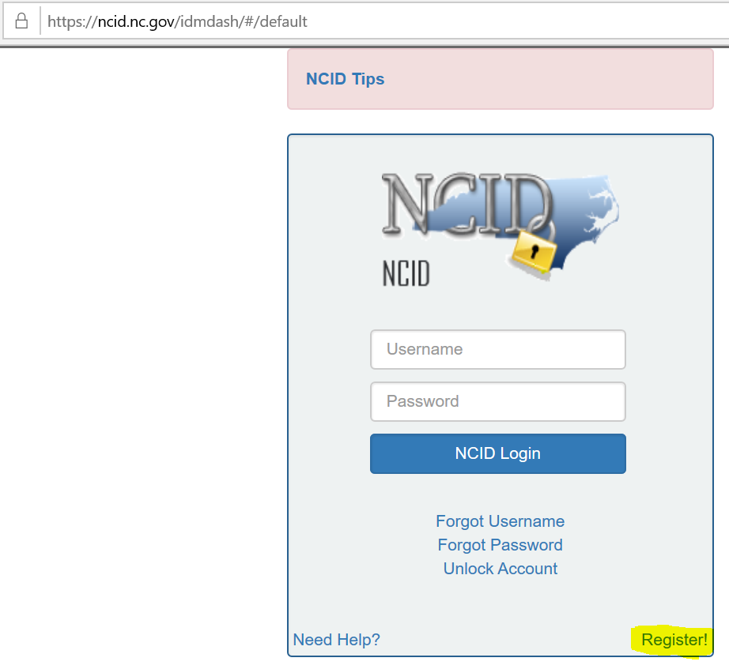

2). Select Register link

3). Select the Individual category

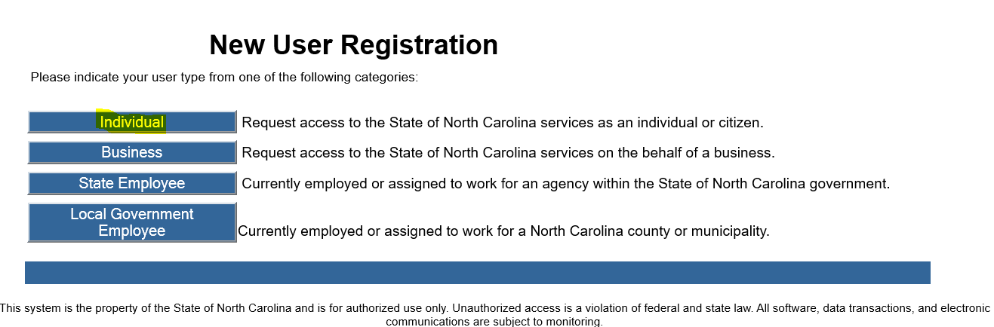

4). Type in your NCID, First Name, Middle Name (if any), Last Name, Email address, Password (remember this because you will need it to login again).

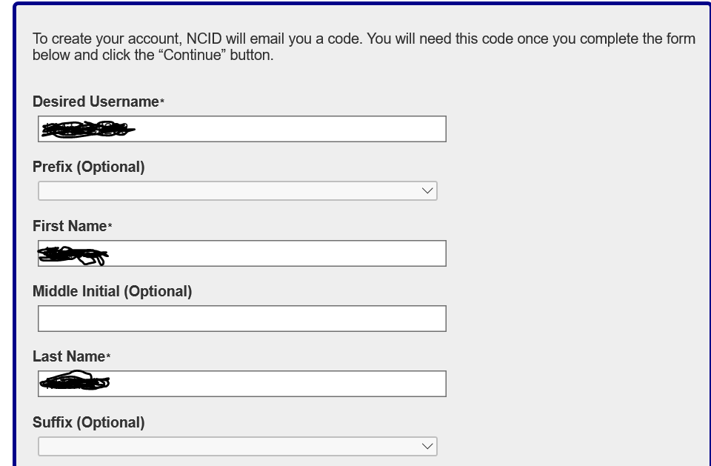

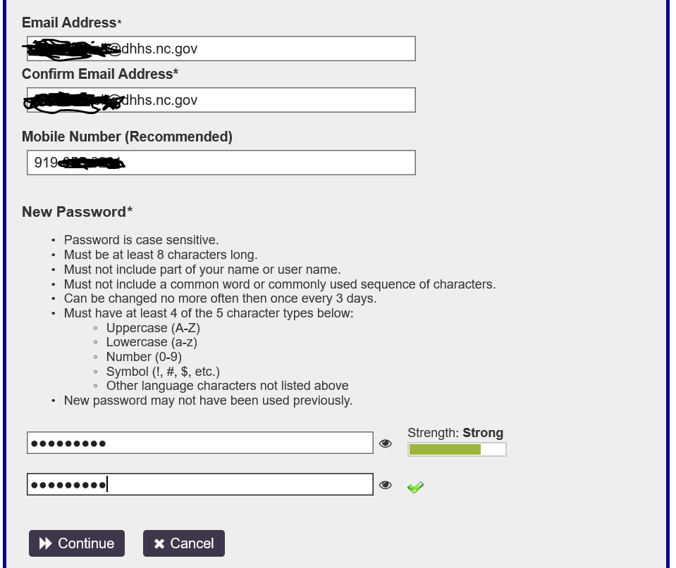

5).  Click Continue.

6). System will send a security code to your given email address like below. Please type in and check the code

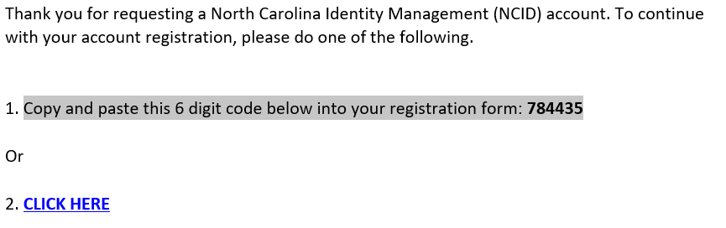

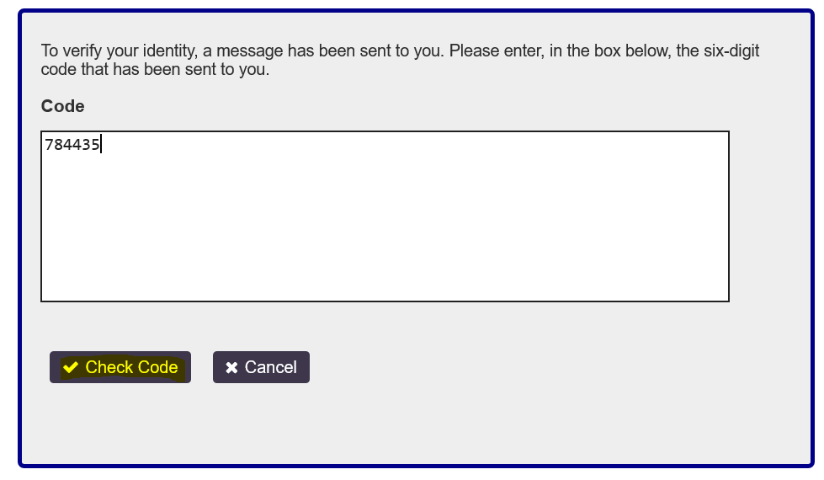

7). Once Code is successful click Continue.

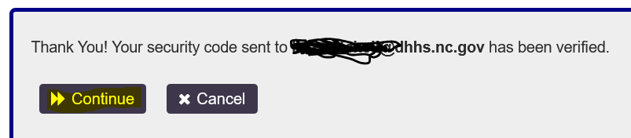

8). Once redirected type in your Credentials which you used while registering.

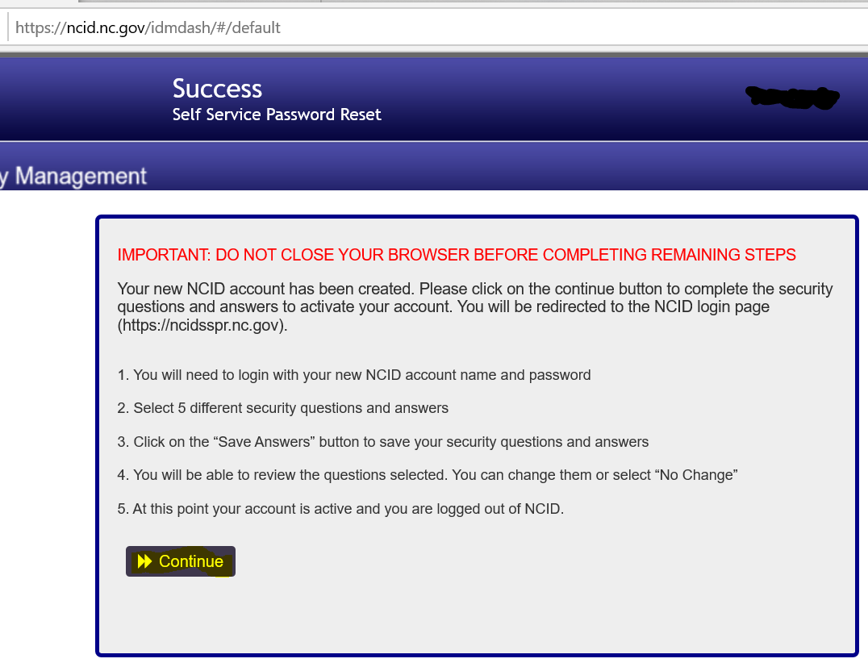

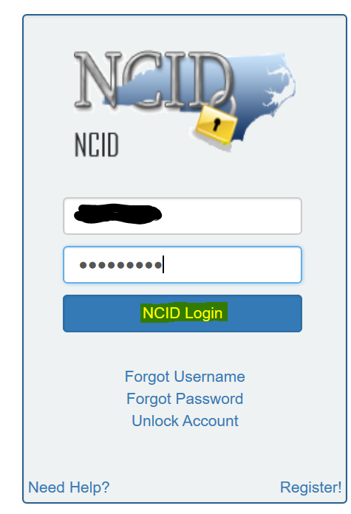

9). Once you are logged-in you will see the Security questions page where you answer the security questions ( remember the answers or save it in notepad as it will be useful in future if you are locked-in or forgot your password)

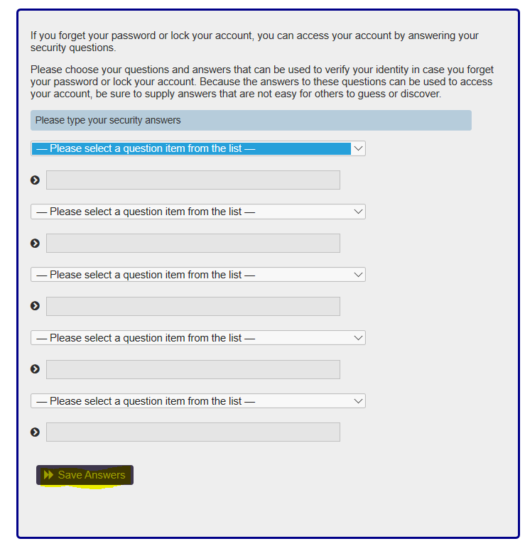

10). Save the answers.