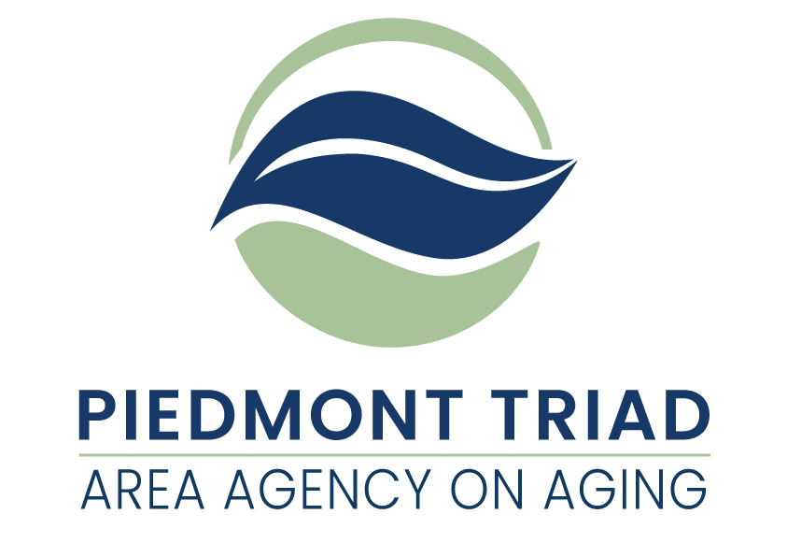

**American Rescue Plan Act**

Supportive Services Legal Services Grants Available

This Request for Application (RFA) is for grant proposals funded by the American Rescue Plan Act of 2021 (ARPA). ARPA funds provide a unique opportunity to consider needs and service delivery that have the potential to respond to unmet needs of older adults and family caregivers. The Piedmont Triad Regional Council Area Agency on Aging (PTRC AAA) is taking a regional approach in distributing these funds based on the priorities established by the North Carolina Division of Aging and Adult Services.  Service match is not required, and funds will remain available until expended or until September 30, 2024, whichever comes first.

The project period for this funding is December 1, 2023 through September 30, 2024. All ARPA funds must be obligated by September 30, 2024.

Additional information is available on the PTRC website under the specific Supportive Services links at <http://www.ptrc.org/services/pandemic-recovery-funding-opportunities>.

**PTRC AAA is making ARPA Legal Services grants available in the amount of up to $185,710.00. These funds are available to Legal Services providers in one or more of the following counties: Alamance, Caswell, Davidson, Davie, Forsyth, Guilford, Montgomery, Randolph, Rockingham, Stokes, Surry and Yadkin. Funds are for providing legal assistance to people age 60 years of age or older under the Older Americans Act (“OAA”). The legal assistance program, also referred to as the legal services program, is intended to protect and secure the rights, benefits, and dignity of older persons.**

**Priority consideration will be given to proposals that address the needs of older adults who are underserved and/or underrepresented.**

**ARPA Legal Services Grant Overview**

Legal services are defined, in part, as legal advice or representation provided to older adults with economic or social needs. Legal services provide individuals who are 60 years of age or older with either: 1) legal advice and/or legal representation, 2) appropriate referrals to human services agencies including probono legal services or 3) utilizing preventative measures such as community education and outreach to prevent legal issues from arising.

**Eligibility Requirements for Legal Services**

Clients eligible for legal services must be 60 years of age or older, need legal assistance, and not be excluded from receiving legal services under federal law, state law, or prohibited as outlined in the NC Department of Health and Human Services, Division of Aging and Adult Services, Legal Services Program Manual (updated December 1, 2021). Excluded legal services include but are not limited to legal assistance regarding lobbying, political activities, etc.

Under the Older Americans Act, means testing is prohibited. Consequently, a legal services provider may ask a potential client about their financial circumstances in order to assign them to the most appropriate funding source for their situation or to determine if the potential client is requesting legal services which exceed the scope of legal representation provided under the Older Americans Act by the legal services provider (e.g., trusts or estate administration). However, the legal services provider is prohibited from asking a potential client about their financial circumstances in order to deny that individual legal services under the Older Americans Act solely because of the potential client’s income status. Once a client has been accepted for legal services, validation of income to provide effective legal advice, counseling, or legal representation is permissible under the Older Americans Act. An older individual is determined to move from the status of potential client to client once the older individual has been notified by the legal services provider, regardless if notification is made verbally or in writing, that he/she/they is eligible for legal services.

**Targeted Population for Legal Services**

Legal services providers serving North Carolina under the Older Americans Act will use outreach efforts to focus on the following groups:

* Older individuals residing in rural areas;
* Older individuals with greatest economic needs, with particular attention to low income minority individuals;
* Older individuals with greatest social need, with particular attention to low income minority individuals;
* Older individuals with severe disabilities;
* Older individuals with limited English proficiency;
* Older individuals with Alzheimer’s disease and related disorders with neurological and organic brain dysfunction (and the caretakers of such individuals); and
* Older individuals at risk for institutional placement.

**Service Priority for Legal Services**

The Older Americans Act specifies that legal services providers shall give priority to legal cases related to:

* Income
* Health Care
* Long Term Care
* Nutrition
* Housing
* Utilities
* Defense of Guardianship or Protective Services (i.e., defending an older person against the imposition of guardianship or protective services)
* Abuse, Neglect, and Exploitation
* Age Discrimination
* Other (This category should be used sparingly when the legal service rendered does not fall within any of the above categories.)

**Excluded Legal Services**

Excluded legal services include legal assistance regarding lobbying and political activities. In addition,

a legal services provider, or an employee of a legal services provider, is prohibited from using Older Americans Act resources to participate in public demonstrations, picketing, boycotting, strikes, or to encourage others to engage in such activities or at any time, engage in or encourage others to engage in illegal activity. Consequently, legal services providers shall not provide services for criminal law matters.

**Staffing**

Legal services to older individuals with economic or social needs must be provided by a licensed attorney. When feasible, a non-attorney, including but not limited to a law student or paralegal, may assist in providing counseling or other appropriate assistance, providing that non-attorney individual is under the direct supervision of an attorney.

An attorney shall adhere to the following NC Rules of Professional Conduct: Rule 1.6, Confidentiality of Information, and Rule 1.7, Conflict of Interest: Current Clients.

If a legal services provider is not a Legal Services Corporation, then the legal services provider shall coordinate its services with Legal Services Corporation projects in an effort to efficiently serve those with the greatest social and economic need.

**Reporting Requirements for ARPA Legal Services**

All legal services providers are required to collect the following information for each accepted legal case as is required by the Federal Administration for Community Living (ACL):

* Client Demographics: Age and Date of Birth, Gender, Geographic Distribution (Urban v. Rural), Household Status, Poverty Status, Race, Ethnicity, Minority Status.
* Case Specifics: Opening Date, Closed Date, Case Type, Case Intensity.

This data shall be recorded in conjunction with the federal government fiscal year so that the first of the year begins on October 1st and the fiscal year closes on September 30th. This data shall be reported biannually on March 30th and September 30th of each year to the NC Division of Aging and Adult Services Legal Services Developer through the PTRC Area Agency on Aging.

A list of presentations conducted by legal services providers discussing legal issues affecting older adults shall be supplied to the PTRC Area Agency on Aging at the end of each state fiscal year (June 30th).

**Consumer Contributions Requirements for ARPA Legal Services**

* Consumer Contributions must be solicited and properly documented for each eligible participant receiving services through ARPA Legal Services funding.
* Consistent with DAAS Administrative Letter 13-08, a legal services provider may discuss or solicit consumer contributions at any time during the course of rendering services and is not required to request or discuss consumer contributions at the start of services. Consequently, legal services providers may elect to provide the consumer contributions form to the client at the end of the attorney-client relationship in collaboration with a closing file letter.

**Cost Computation Requirements for Legal Services**

Accurately completed Cost Computation forms will be required of all Legal Services grant awardees.

**Reimbursement for ARPA Legal Services**

**ARPA Legal Services are handled through a reimbursement system.** ARPA Legal Services is a unit-based service. Legal services shall be reported in the Aging Resources Management System (ARMS) for reimbursement in accordance with the number of units provided. A unit of service equals one (1) case hour.

**Monitoring**

All services provided by ARPA Legal Services funds will be monitored by the PTRC Area Agency on Aging (PTRC AAA) according to a timeline established by the North Carolina Division of Aging and Adult Services. Monitoring will be conducted following the “PTRC AAA Policies and Procedures for Monitoring” (November 2016).

**Confidentiality and Security**

Client information in any format and whether recorded or not shall be kept confidential and not disclosed in a form that identifies the person without the informed consent of the person or legal representative. Community service providers, including subcontractors and vendors, must adhere to all applicable federal, state, and departmental requirements for protecting the security and confidentiality of client information including, but not limited to appropriately restricting access, establishing procedures to reduce the risk of accidental disclosures from data processing systems, and developing a process by which the North Carolina Division of Aging and Adult Services is notified of suspected or confirmed security incidents and data breaches.

**Record Retention and Disposition**

All community service providers are responsible for maintaining custody of records and documentation to support the allowable expenditure of funds, service provision, and the reimbursement of services. Service providers must adhere to the approved record retention and disposition schedule posted semiannually on the website of the NC Department of Health and Human Services (DHHS) Controller at:

<https://www.ncdhhs.gov/about/administrative-offices/office-controller/records-retention>

Service providers are not authorized to destroy records related to the provision of services under this Agreement except in compliance with the approved DHHS retention and disposition schedule, which allows for the proper destruction of records based on a schedule by funding source and fiscal year. Confidential records will be destroyed in such a manner that the records cannot be practically read or reconstructed.

**Project Period**

The Project Period for ARPA Legal Services funds is December 1, 2023 through September 30, 2024.

**PTRC AAA reserves the right to reject any or all applications, waive technicalities, and to be the sole judge of suitability of the services for their intended use, and further specifically reserves the right to make the award in the best interest of the PTRC AAA regional program.**

**Submitting an Application for** **ARPA Legal Services**

**Three copies of the Request for Application (RFA) with original signatures** must be submitted to PTRC AAA, 1398 Carrollton Crossing Drive, Kernersville NC 27284 - Attention Gwen Shields by November 15, 2023, at 4:00 pm. Applications received after this date and time will not be considered for funding.

Proposals that best meet PTRC Area Agency on Aging (AAA) expectations for service delivery will be selected.

Applications will be scored based on their completeness and their description of intent to provide services.

All questions regarding the RFA must be submitted in writing by November 3, 2023, at 4:00 pm, to [gshields@ptrc.org](mailto:gshields@ptrc.org) . After such time, and until projects are awarded, Applicants are prohibited from contacting PTRC AAA staff regarding any issue relating to these funds or the application process.

**PTRC AAA reserves the right to reject any or all applications, waive technicalities, and to be the sole judge of suitability of the services for their intended use, and further specifically reserves the right to make the award in the best interest of the PTRC AAA regional program.**

Failure to respond to any requirements outlined in the RFA, or failure to enclose completed copies of the required documents, may disqualify the application.

|  |  |
| --- | --- |
| **Timeline** | **Date** |
| Announcement of Funding Availability | Wednesday, October 18, 2023 |
| Final day to submit questions | Friday, November 3, 2023 |
| Applications Due | Wednesday, November 15, 2023 |
| Award Announcement | December 2023 |

**Evaluation Criteria**

PTRC AAA has developed a scoring tool to evaluate applications. The tool will be available on the PTRC website under the Legal Services link at <http://www.ptrc.org/services/pandemic-recovery-funding-opportunities>.  Proposals that best meet PTRC AAA expectations for service delivery will be selected. Applications will be scored based on their completeness and their description of intent to provide services. Priority consideration will be given to proposals that address the needs of older adults who are underserved and/or, underrepresented.

**Available Funding**

Use the following allocation to develop your funding request(s). Requests must be reasonable, necessary, and justifiable.

**Legal Services grants of up to $185,710**

All expenditures must be reasonable, necessary, and justifiable. All funds must be spent on client services related to ARPA Legal Services. An organization may submit applications to provide ARPA Legal Services in multiple counties. If applying for multiple counties, each county will require its own application. Each application will be reviewed separately. Requested total of grant amounts cannot exceed $185,710.

**Monitoring**

All services provided by ARPA Legal Services funds will be monitored by the PTRC Area Agency on Aging (PTRC AAA) according to a timeline established by the North Carolina Division of Aging and Adult Services. Monitoring will be conducted following the “PTRC AAA Policies and Procedures for Monitoring” (November 2016).

**ARPA Legal Services**

**Request for Application**

**Three copies of the Request for Applications (RFA) with original signatures** must be submitted to PTRC AAA, 1398 Carrollton Crossing Drive, Kernersville NC 27284 - Attention Gwen Shields by November 15, 2023, at 4:00 pm. Applications received after this date and time will not be considered for funding. Request must be reasonable, necessary, and justifiable.

**Project Contact Information**

Organization **(Full Legal Name Required)**:

Project Director: Title:

Mailing Address:

Phone Number: Email:

Board Chair (if applicable): Email:

Tax ID # **(required)**:

SAMS Unique Entity ID (UEI) # **(Valid number required)**:

Type of agency:

Non-profit  For-profit  Government  Other  Specify _____________

**Required Information:** Submit one copy of your organization’s most recent financial statements (audited or unaudited). For those organizations submitting unaudited financial statements, a completed State Grant Certification and Sworn Statement and a completed Schedule of Receipts and Expenditures are also required. Additional information may be requested.

**Application Questions** *You many expand on the space provided. Word count is not limited.*

1. Under the Older Americans Act, legal services are defined as “legal advice and representation by an attorney to older adults with economic or social need.” How does your agency target those older adults with the greatest economic need? AND How does your agency target those older adults with the greatest social need?
2. Does your agency render legal services to those regardless of their immigration status?
3. If two (2) potential clients are competing for legal services funding, what process has your agency established to ensure the targeted populations as listed under the Older Americans Act (see section above) receive legal services over the potential client who does not fall under the targeted populations?

Use the following budget request to propose funding needs to support legal services:

Provide a basic budget describing how the funds will support legal services. Please be as specific as possible.

**Upon award of the grant, an official budget will be completed using the required Cost Computation forms.**

Grant Amount Requested:       Location/County to Serve:

|  |  |
| --- | --- |
| Expense Categories | Budget |
| Personnel Costs (itemize below) |  |
| Operating Costs (itemize below) |  |
| **TOTAL EXPENSES** |  |

|  |  |
| --- | --- |
| Itemized Categories | Budget |
| Personnel Costs (itemize by Name & Position):  TOTAL |  |
| Operating Costs (Itemize by Type):    TOTAL |  |
| **TOTAL EXPENSES** |  |

**American Rescue Plan Act (ARPA) Bid Certification Statement**

**By signing and submitting its bid or proposal, the bidder or proposer certifies as follows:**

The certification in this clause is a material representation of fact relied upon by the AGENCY. If it is later determined by the AGENCY that the bidder or proposer knowingly rendered an erroneous certification, in addition to remedies available to the AGENCY, the Federal Government may pursue available remedies, including but not limited to suspension and/or debarment. The bidder or proposer agrees to comply with the requirements of 2 C.F.R. part 180, subpart C, as supplemented by 2 C.F.R. part 1200, while this offer is valid and throughout the period of any contract that may arise from this offer. The bidder or proposer further agrees to include a provision requiring such compliance in its lower tier covered transactions.

**Execution**

In compliance with this Request for Application (RFA) the undersigned Applicant offers and agrees to furnish and deliver any or all services proposed, at the budget proposed, and within the timeframe specified herein. By executing this Application, the undersigned Applicant confirms that it has read, understands and will comply with all specifications and requirements of this grant in the event of contract award.

PRINT NAME: _____________________________________________________________________

AUTHORIZED SIGNATURE: ___________________________________________________________

TITLE: _________________________________________________ DATE: ______________________

**PTRC AAA reserves the right to reject any or all applications, waive technicalities, and to be the sole judge of suitability of the services for their intended use, and further specifically reserves the right to make the award in the best interest of the PTRC AAA regional program.**