

**Piedmont Triad Regional Council**

**Executive Committee**

**Agenda**

Wednesday, February 5, 2020

12:00 noon

PTRC Headquarters

1398 Carrollton Crossing Drive

Kernersville, NC 27284

***Item*** ***Official***

***Lunch***  **Katie Mitchell**

*Please note the 11:45 a.m. lunch start time and join us as Clerk to the Board*

*you are able.* *RSVP to Katie Mitchell at (336)904-0345*

*or by email at kmitchell@ptrc.org.*

**Members**

**Counties**

**Alamance**

**Caswell**

**Davidson**

**Davie**

**Forsyth**

**Guilford**

**Montgomery**

**Randolph**

**Rockingham**

**Stokes**

**Surry**

**Yadkin**

**Municipalities**

**Archdale**

**Asheboro**

**Bermuda Run**

**Bethania**

**Biscoe**

**Boonville**

**Burlington**

**Candor**

**Clemmons**

**Cooleemee**

**Danbury**

**Denton**

**Dobson**

**East Bend**

**Eden**

**Elkin**

**Elon**

**Franklinville**

**Gibsonville**

**Graham**

**Green Level**

**Greensboro**

**Haw River**

**High Point**

**Jamestown**

**Jonesville**

**Kernersville**

**King**

**Lewisville**

**Lexington**

**Liberty**

**Madison**

**Mayodan**

**Mebane**

**Midway**

**Mocksville**

**Mount Airy**

**Mt. Gilead**

**Oak Ridge**

**Pilot Mountain**

**Pleasant Garden**

**Ramseur**

**Randleman**

**Reidsville**

**Rural Hall**

**Seagrove**

**Sedalia**

**Stokesdale**

**Stoneville**

**Summerfield**

**Thomasville**

**Tobaccoville**

**Trinity**

**Troy**

**Village of Alamance**

**Walkertown**

**Wallburg**

**Walnut Cove**

**Wentworth**

**Winston-Salem**

**Yadkinville**

**Yanceyville**

**A. Call to Order, Welcome, Moment of Kevin Austin**

**Silence, and Pledge of Allegiance** *Chair*

**B. Action Items**

1. **Request for approval of December 4, 2019 Kevin Austin**

**PTRC Executive Committee Minutes** *(attachment)**Chair*

1. **Request for approval for PTRDC Board Jesse Day**

**Appointment** *Planning Director*

**3) Request for authorization to enter into contract Adrienne Calhoun with MIPPA in the amount of $69,924** *AAA Director*

**4) Request for authorization to apply for and accept Matthew Dolge**

**EDA Disaster Funds in the amount of $2,890,000** *Executive Director*

**for revitalization of the Surry County Spencer**

**Mills facility**

**5) Request for authorization to enter into contract Cameron Colvin**

**with the Triangle J COG for $25,000 to help** *Regional Planner*

**facilitate the Jordan Lake One Water process**

**6) Request for approval to enter into contract with Jesse Day**

**the Town of Lewisville for stormwater mapping** *Planning Director*

**services not to exceed $30,000**

**C. Executive Director’s Report Matthew Dolge** *Executive Director*

**D. Old Business Kevin Austin**

*Chair*

*]* **E. New Business Kevin Austin** *Chair*

**F. Around the Region Kevin Austin**

*At this time, Board members are asked to discuss any Chair*

*upcoming events or informational items that pertain to*

*their local government or region.*

**G. Chairman’s Remarks and Announcements Kevin Austin**  *Chair*

1. **PTRC Executive Committee Meeting**

Wednesday, March 4, 2020 11:45 a.m.

**Piedmont Triad Regional Council**

**1398 Carrollton Crossing Drive**

**Kernersville, NC 27284**

1. **PTRC Board of Delegates Meeting**

Wednesday, February 19, 2020 11:45 a.m.

**Piedmont Triad Regional Council**

**1398 Carrollton Crossing Drive**

**Kernersville, NC 27284**

1. **2020 PTRC Meeting Dates**

**H. Informational Items**

**1) Change of Auditors FY 2019-2020**

**2) Monitoring response for ESFRLP- Davie County**

**M-E-M-O-R-A-N-D-U-M**

**ACTION ITEM #2**

TO: Executive Committee, Piedmont Triad Regional Council

FROM: Jesse Day, Regional Planning Director

DATE: February 5, 2020

RE: PTRDC Board Member Appointment

County Representatives

Casey Smith has been appointed by the Davidson County Board of Commissioners to fill the vacancy left by Zeb Hanner’s retirement on the PTRDC Board.

|  |  |  |  |
| --- | --- | --- | --- |
| Location | Delegate | Title | Term Ending |
| Davidson County | Casey Smith | County Manager | January 2020 |

**ACTION ITEM #3**

**M-E-M-O-R-A-N-D-U-M**

TO: Executive Committee, Piedmont Triad Regional Council

FROM: Adrienne Calhoun, Aging Director, Area Agency on Aging

DATE: February 5, 2020

RE: Request for authorization to enter into contract with the North Carolina Department of Insurance for Medicare Improvements for Patients and Providers Act 2008 (MIPPA) in the amount of $69,924 for the period of October 1, 2019 to September 30, 2020.

Area Agencies on Aging (AAA) across North Carolina are working with Senior Health Insurance Information Programs (SHIIP) to outreach to older adults and individuals who have mental or physical disabilities who are eligible for Low Income Subsidized Medicare benefits. The PTRC Area Agency on Aging has been awarded $69,924 to provide outreach and education across the region.

This allocation will allow the AAA to identify potential beneficiaries throughout the region using varies methods and targeted outreach. We will use all connections we have to leverage an increased number of people. In anticipation of this funding, we have already discussed targeting methods with SHIIP coordinators to effectively service our counties.

**ACTION REQUESTED:**

PTRC AAA request authorization to enter into contract for $69,924 with the North Carolina Department of Insurance for Medicare Improvements for Patients and Providers Act 2008, (MIPPA) funding for the period October 1, 2019 to September 30, 2020.

**M-E-M-O-R-A-N-D-U-M**

**ACTION ITEM #4**

TO: Executive Committee, Piedmont Triad Regional Council

FROM: Matthew Dolge, Executive Director

DATE: February 5, 2020

RE: Authorization to apply for EDA Disaster Funds to support revitalization of Surry County Spencer Mills facility

The PTRC Workforce Department is seeking approval to apply for Economic Development Association (EDA) Disaster Funds to support revitalization work on the Spencer Mills facility in Surry County. PTRC received an ARC POWER Technical Assistance Grant to study the impact of the decline of the coal industry on the workforce and communities at large in the service area.

Surry County was identified as one of two counties that suffered economic loss that dramatically impacted the overall economy. The Piedmont Triad Regional Council is aware that a proactive approach is required to address the challenges facing this vulnerable county. PTRC has conducted research and developed a strategic plan to address economic changes and workforce impact. This plan includes a state-of-the-art workforce development training and education hub, the Dream. Career. Academy. The Dream. Career. Academy. would address current as well as future workforce needs, serving both adult and youth. The goal of the initiative is to align talent with careers in innovative ways and to identify and engage currently disengaged populations to the workforce by removing barriers for these individuals. The core components of the Dream. Career. Academy. include: Career Exploration, Career Connection, Career Development and Business Support.

The PTRC Workforce Department would utilize the EDA Disaster funds as a critical component to support the revitalization of the Spencer Mills facility to house the Dream. Career. Academy. The grant amount requested is $2,890,000 to be matched with funds from the City of Mount Airy.

**ACTION REQUESTED:**

Request authorization to apply for and accept EDA Disaster Funds in the amount of $2,890,000 for the revitalization of the Surry County Spencer Mills facility.

**M-E-M-O-R-A-N-D-U-M**

**ACTION ITEM #5**

TO: Executive Committee, Piedmont Triad Regional Council

FROM: Cameron Colvin, Regional Planner I

DATE: February 5, 2020

RE: Authorization to enter into contract with the Triangle J Council of Governments to help facilitate the Jordan Lake One Water stakeholder engagement process

The Jordan Lake Watershed is a massive regional resource that is utilized by 10 counties, 27 municipalities, and nearly 700,000 water customers. Since its impoundment in 1983, Jordan Lake has been considered a Nutrient Sensitive Water and consistently failed to meet state and federal water quality standards. In an attempt to restore water quality, the state passed the Jordan Lake Rules in 2009, which established requirements in the Jordan Lake watershed for wastewater discharges, buffers, agricultural activities and fertilizer use, and stormwater management in new and existing development. These rules have been highly contentious and certain requirements of the rules have been placed on hold while the NC Policy Collaboratory conducts a multi-year study to evaluate the cost and benefits of the rules and the effect they have had thus far. This contention has led to a lack of communication across the watershed and predominantly resulted in local governments “going it alone” and spending large amounts of money for small nutrient reductions.

As a result, many local governments have recognized the need for an alternative integrated watershed management (or “One Water”) approach that allows for greater collaboration, sharing of resources, knowledge, and expertise. Interest in integrated watershed management was so high that PTRC and the Triangle J Council of Governments (TJCOG) began hosting regular Jordan Lake stakeholder meetings, where attendees could learn about One Water; share perspectives, challenges, and possibilities; and begin envisioning what such an approach would look like in the Jordan Lake watershed. These meetings bring together an average of 60+ representatives of organizations and stakeholders from across the watershed, many of which have never considered collaborating across jurisdictions to achieve tangible watershed-wide benefits. The conversations at these meetings are unprecedented and implementing such an approach in the Jordan Lake watershed would be the first of its kind in the state.

Since that time, the Jordan Lake One Water (JLOW) group has gathered the support of several elected officials and various state departments – so much so that the NC Division of Water Resources has agreed to partner with JLOW to supplement the Jordan Lake Rules re-adoption process and provide grant funding to support the development of an integrated watershed management “One Water” framework for the Jordan Lake watershed that provides detailed policy, operational, and financial recommendations. This effort will require a rigorous stakeholder engagement process that will be facilitated by TJCOG with assistance from PTRC over the next year and a half. The primary goals of this project are to 1) identify and define local and watershed-wide goals and benefits, 2) identify integrated watershed management implementation opportunities, 3) develop evaluation methods for projects, 4) determine feasible monitoring and reporting procedure, 4) evaluate potential financing structures, and 5) evaluate potential organizational structures, through voluntary stakeholder workgroups.

**ACTION ITEM #5 CONTINUED**

**Contract Amount:** $25,000

**Project Timeline:** January 2020 – June 2021

**Match Requirements:** None

**ACTION REQUESTED:**

The PTRC Planning Department requests authorization to enter into contract with the Triangle J Council of Governments for $25,000 to help facilitate the Jordan Lake One Water stakeholder engagement process

**M-E-M-O-R-A-N-D-U-M**

**ACTION ITEM #6**

TO: Executive Committee, Piedmont Triad Regional Council

FROM: Jesse B. Day, Regional Planning Director

DATE: February 5, 2020

RE: Lewisville Stormwater Mapping Project

The Planning Department requests to enter into contract for planning services with the Town of Lewisville. The work will consist of mapping stormwater infrastructure and field work will take place March 2020 to December 2020. Working with public works and planning staff, the storm drains, drainage ditches, and other stormwater control measures will be mapped and incorporated into a digital GIS database using GPS systems for future use in development, re-development and infrastructure planning.

**The Town of Lewisville has approved this contract.**

**ACTION REQUESTED:**

Request for approval to enter into contract with the Town of Lewisville for stormwater mapping services not to exceed $30,000 from January 1, 2020 to December 30, 2020.

**M-E-M-O-R-A-N-D-U-M**

**INFORMATIONAL ITEM #1**

TO: Executive Committee, Piedmont Triad Regional Council

FROM:         Jarrod Hand, Finance Director

DATE:           February 5, 2020

RE:              Information about change of Auditors for FY 2019-2020

The Finance Department has issued a request-for-proposal for auditing services for FY 2019-2020, 2020-2021 & 2021-2022. Effective immediately, Cannon & Company LLP has elected not to provide audit services for governmental entities. Valerie Kiger, Partner, stated the due to trends in the audit industry and greater regulations and requirements, Cannon & Co LLP cannot perform these types of engagements in an effective and efficient manner.

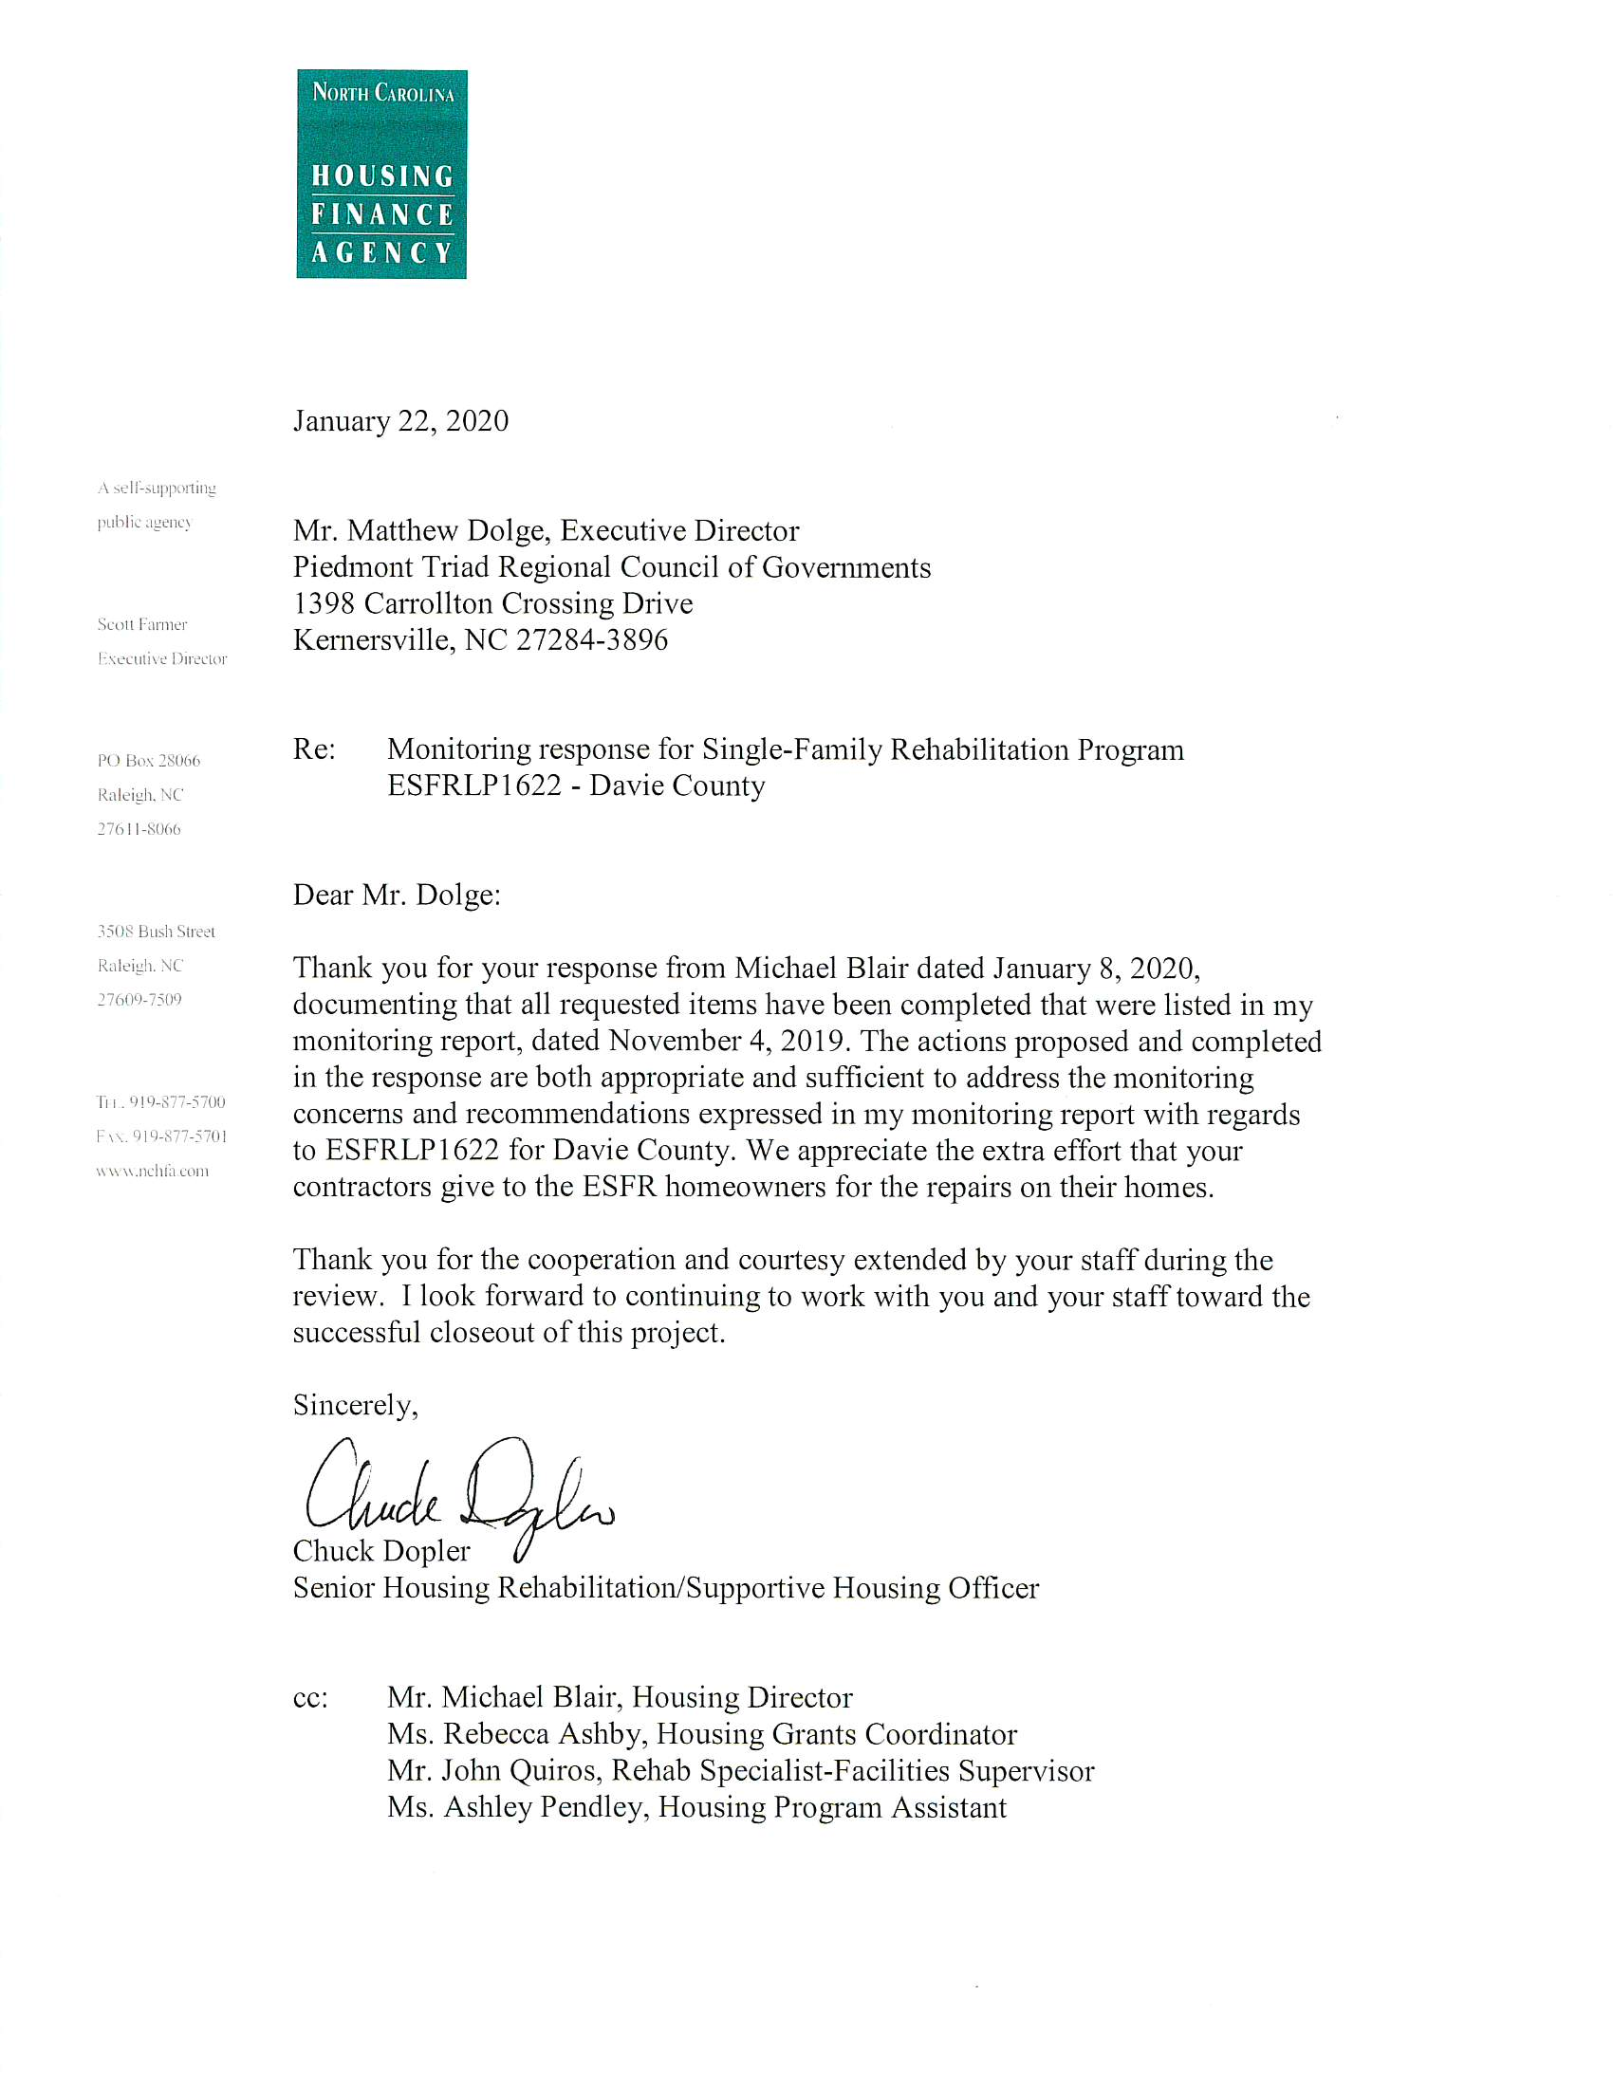

**INFORMATIONAL ITEM #2**

**M-E-M-O-R-A-N-D-U-M**

**ADDITION- ACTION ITEM #7**

TO:  Executive Committee, Piedmont Triad Regional Council

FROM: Michael Blair, Community Development Director

DATE: February 5, 2019

RE: Request for Approval of Weatherization Program Budget Revision for FY 2019-2020

The Community Development requests approval of an amendment to the 2019-2020 Weatherization Assistance Program contract between NC Division of Environmental Quality and the Piedmont Triad Regional Council.  The North Carolina Department of Environmental Quality (DEQ)/Weatherization Assistance Program (WAP) has provided additional funding of:

* DOE WAP of $14,800 (2 Units) for a total revised budget of $623,926;
* LIHEAP WAP of $24,484 (3 units) for a total revised budget of $1,252,252; and
* LIHEAP HARRP of $54,520 (8 units) for a total revised budget of $54,520.

It is recommended that the board adopt this contract amendment to recognize a net increase of $93,804 in the Community Development/WAP 2019-2020 contract.

**ACTION REQUESTED**: The PTRC Community Development Department is requesting approval from the board to accept this new NC DEQ/WAP funding.

**M-E-M-O-R-A-N-D-U-M**

**ADDITION- ACTION ITEM #8**

TO: Executive Committee, Piedmont Triad Regional Council

FROM: Matthew Dolge, Executive Director

DATE: February 5, 2020

RE: Request for authorization to improve parking facilities

The PTRC headquarters facility has been a regional resource for convening meetings, gathering stakeholders, and furthering the mission of the Regional Council. However, parking is limited at our facility. Overflow parking has been attempted along Carrollton Crossing Drive and in the adjacent vacant lots. This solution fails when wet weather results in the vacant lots holding water and the surface is muddy. Unfortunately, cars have gotten stuck during such conditions and had to be towed out of the lots. Parking along Carrollton Crossing Drive constricts traffic and reduces large vehicle access. Therefore, this is a request for authority to expend up to $10,000 for parking improvements. The development property owners have given us permission to use the adjacent lot for the purpose of a temporary gravel lot. The plan is to produce approximately 15 spaces. This is a temporary solution to address pressing current needs. The long term plan is to design adequate parking with the plans for facility expansion.

**ACTION REQUESTED:** Specifically, the action requested is permission to expend up to $10,000 to improve parking with the construction of a temporary gravel parking lot.

**Meeting Dates 2020**

**1398 Carrollton Crossing Drive**

**Kernersville, NC 27284**

**12:00 noon**

|  |  |
| --- | --- |
| PTRC Executive Committee  1st Wednesday | PTRC Board of Delegates  3rd Wednesday |
| January - none | **January - none** |
| February 5, 2020 | **February 19, 2020** |
| March 4, 2020 | **March - none** |
| April 1, 2020 | **April 15, 2020** |
| May 6, 2020 | **May - none** |
| June 3, 2020 | **June 17, 2020** |
| July - none | **July - none** |
| August 5, 2020 | **August 19, 2020** |
| September 2, 2020 | **September - none** |
| October 7, 2020 | **October 21, 2020** |
| November 4, 2020 | **November - none** |
| December 2, 2020 | **December 16, 2020** |