

**Piedmont Triad Regional Council**

**Executive Committee**

**Agenda**

Wednesday, March 4, 2020

12:00 noon

PTRC Headquarters

1398 Carrollton Crossing Drive

Kernersville, NC 27284

***Item*** ***Official***

***Lunch***  **Katie Mitchell**

*Please note the 11:45 a.m. lunch start time and join us as Clerk to the Board*

*you are able.* *RSVP to Katie Mitchell at (336)904-0345*

*or by email at kmitchell@ptrc.org.*

**Members**

**Counties**

**Alamance**

**Caswell**

**Davidson**

**Davie**

**Forsyth**

**Guilford**

**Montgomery**

**Randolph**

**Rockingham**

**Stokes**

**Surry**

**Yadkin**

**Municipalities**

**Archdale**

**Asheboro**

**Bermuda Run**

**Bethania**

**Biscoe**

**Boonville**

**Burlington**

**Candor**

**Clemmons**

**Cooleemee**

**Danbury**

**Denton**

**Dobson**

**East Bend**

**Eden**

**Elkin**

**Elon**

**Franklinville**

**Gibsonville**

**Graham**

**Green Level**

**Greensboro**

**Haw River**

**High Point**

**Jamestown**

**Jonesville**

**Kernersville**

**King**

**Lewisville**

**Lexington**

**Liberty**

**Madison**

**Mayodan**

**Mebane**

**Midway**

**Mocksville**

**Mount Airy**

**Mt. Gilead**

**Oak Ridge**

**Pilot Mountain**

**Pleasant Garden**

**Ramseur**

**Randleman**

**Reidsville**

**Rural Hall**

**Seagrove**

**Sedalia**

**Stokesdale**

**Stoneville**

**Summerfield**

**Thomasville**

**Tobaccoville**

**Trinity**

**Troy**

**Village of Alamance**

**Walkertown**

**Wallburg**

**Walnut Cove**

**Wentworth**

**Winston-Salem**

**Yadkinville**

**Yanceyville**

**A. Call to Order, Welcome, Moment of Kevin Austin**

**Silence, and Pledge of Allegiance** *Chair*

**B. Presentation: Healthy Opportunities Update Jen Nixon**

*HOOP*

**C. Action Items**

1. **Request for approval of February 5, 2020 Kevin Austin**

**PTRC Executive Committee Minutes** *(attachment)**Chair*

1. **Request for approval to apply for up to $500,000 Wendy Walker-Fox**

**in GLOW funding** *WFD Director*

1. **Request for approval to enter into contract with Jesse Day**

**various member jurisdictions up to $3,000 to** *Planning Director*

**provide ordinance update services**

**4) Request for approval to accept the awarded Michael Blair**

**NCHFA ESFRLP20 grants** *CD Director*

**D. Executive Director’s Report Matthew Dolge** *Executive Director*

**E. Old Business Kevin Austin**

*Chair*

*]* **F. New Business Kevin Austin** *Chair*

**G. Around the Region Kevin Austin**

*At this time, Board members are asked to discuss any Chair*

*upcoming events or informational items that pertain to*

*their local government or region.*

**H. Chairman’s Remarks and Announcements Kevin Austin**  *Chair*

1. **PTRC Executive Committee Meeting**

Wednesday, May 6, 2020 11:45 a.m.

**Piedmont Triad Regional Council**

**1398 Carrollton Crossing Drive**

**Kernersville, NC 27284**

1. **PTRC Board of Delegates Meeting**

Wednesday, April 15, 2020 11:45 a.m.

**Piedmont Triad Regional Council**

**1398 Carrollton Crossing Drive**

**Kernersville, NC 27284**

1. **2020 PTRC Meeting Dates**

**I. Informational Items**

**1) Triad Tomorrow Summit**

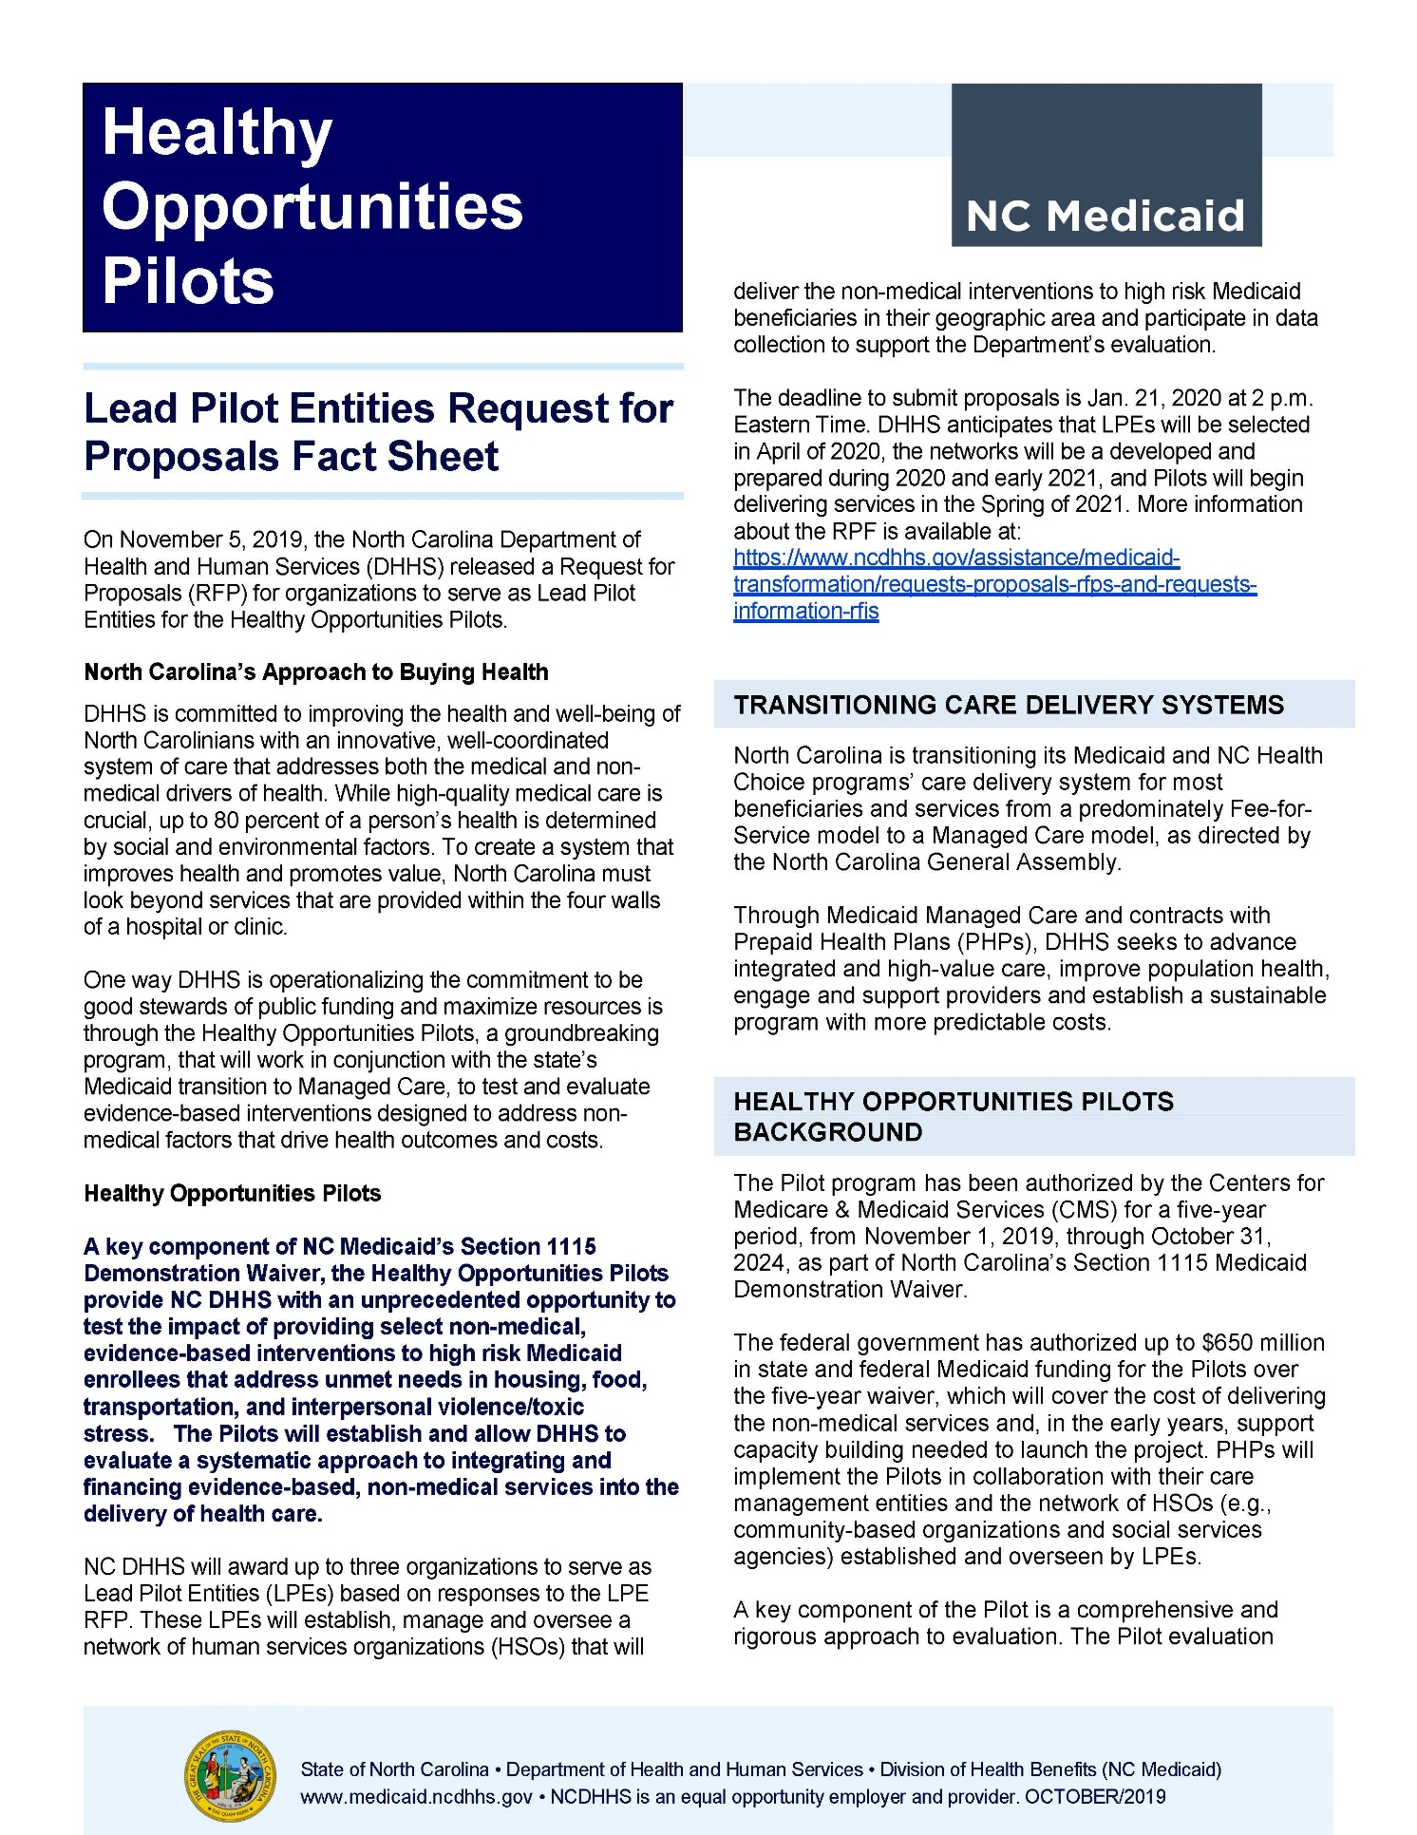

**PRESENTATION**

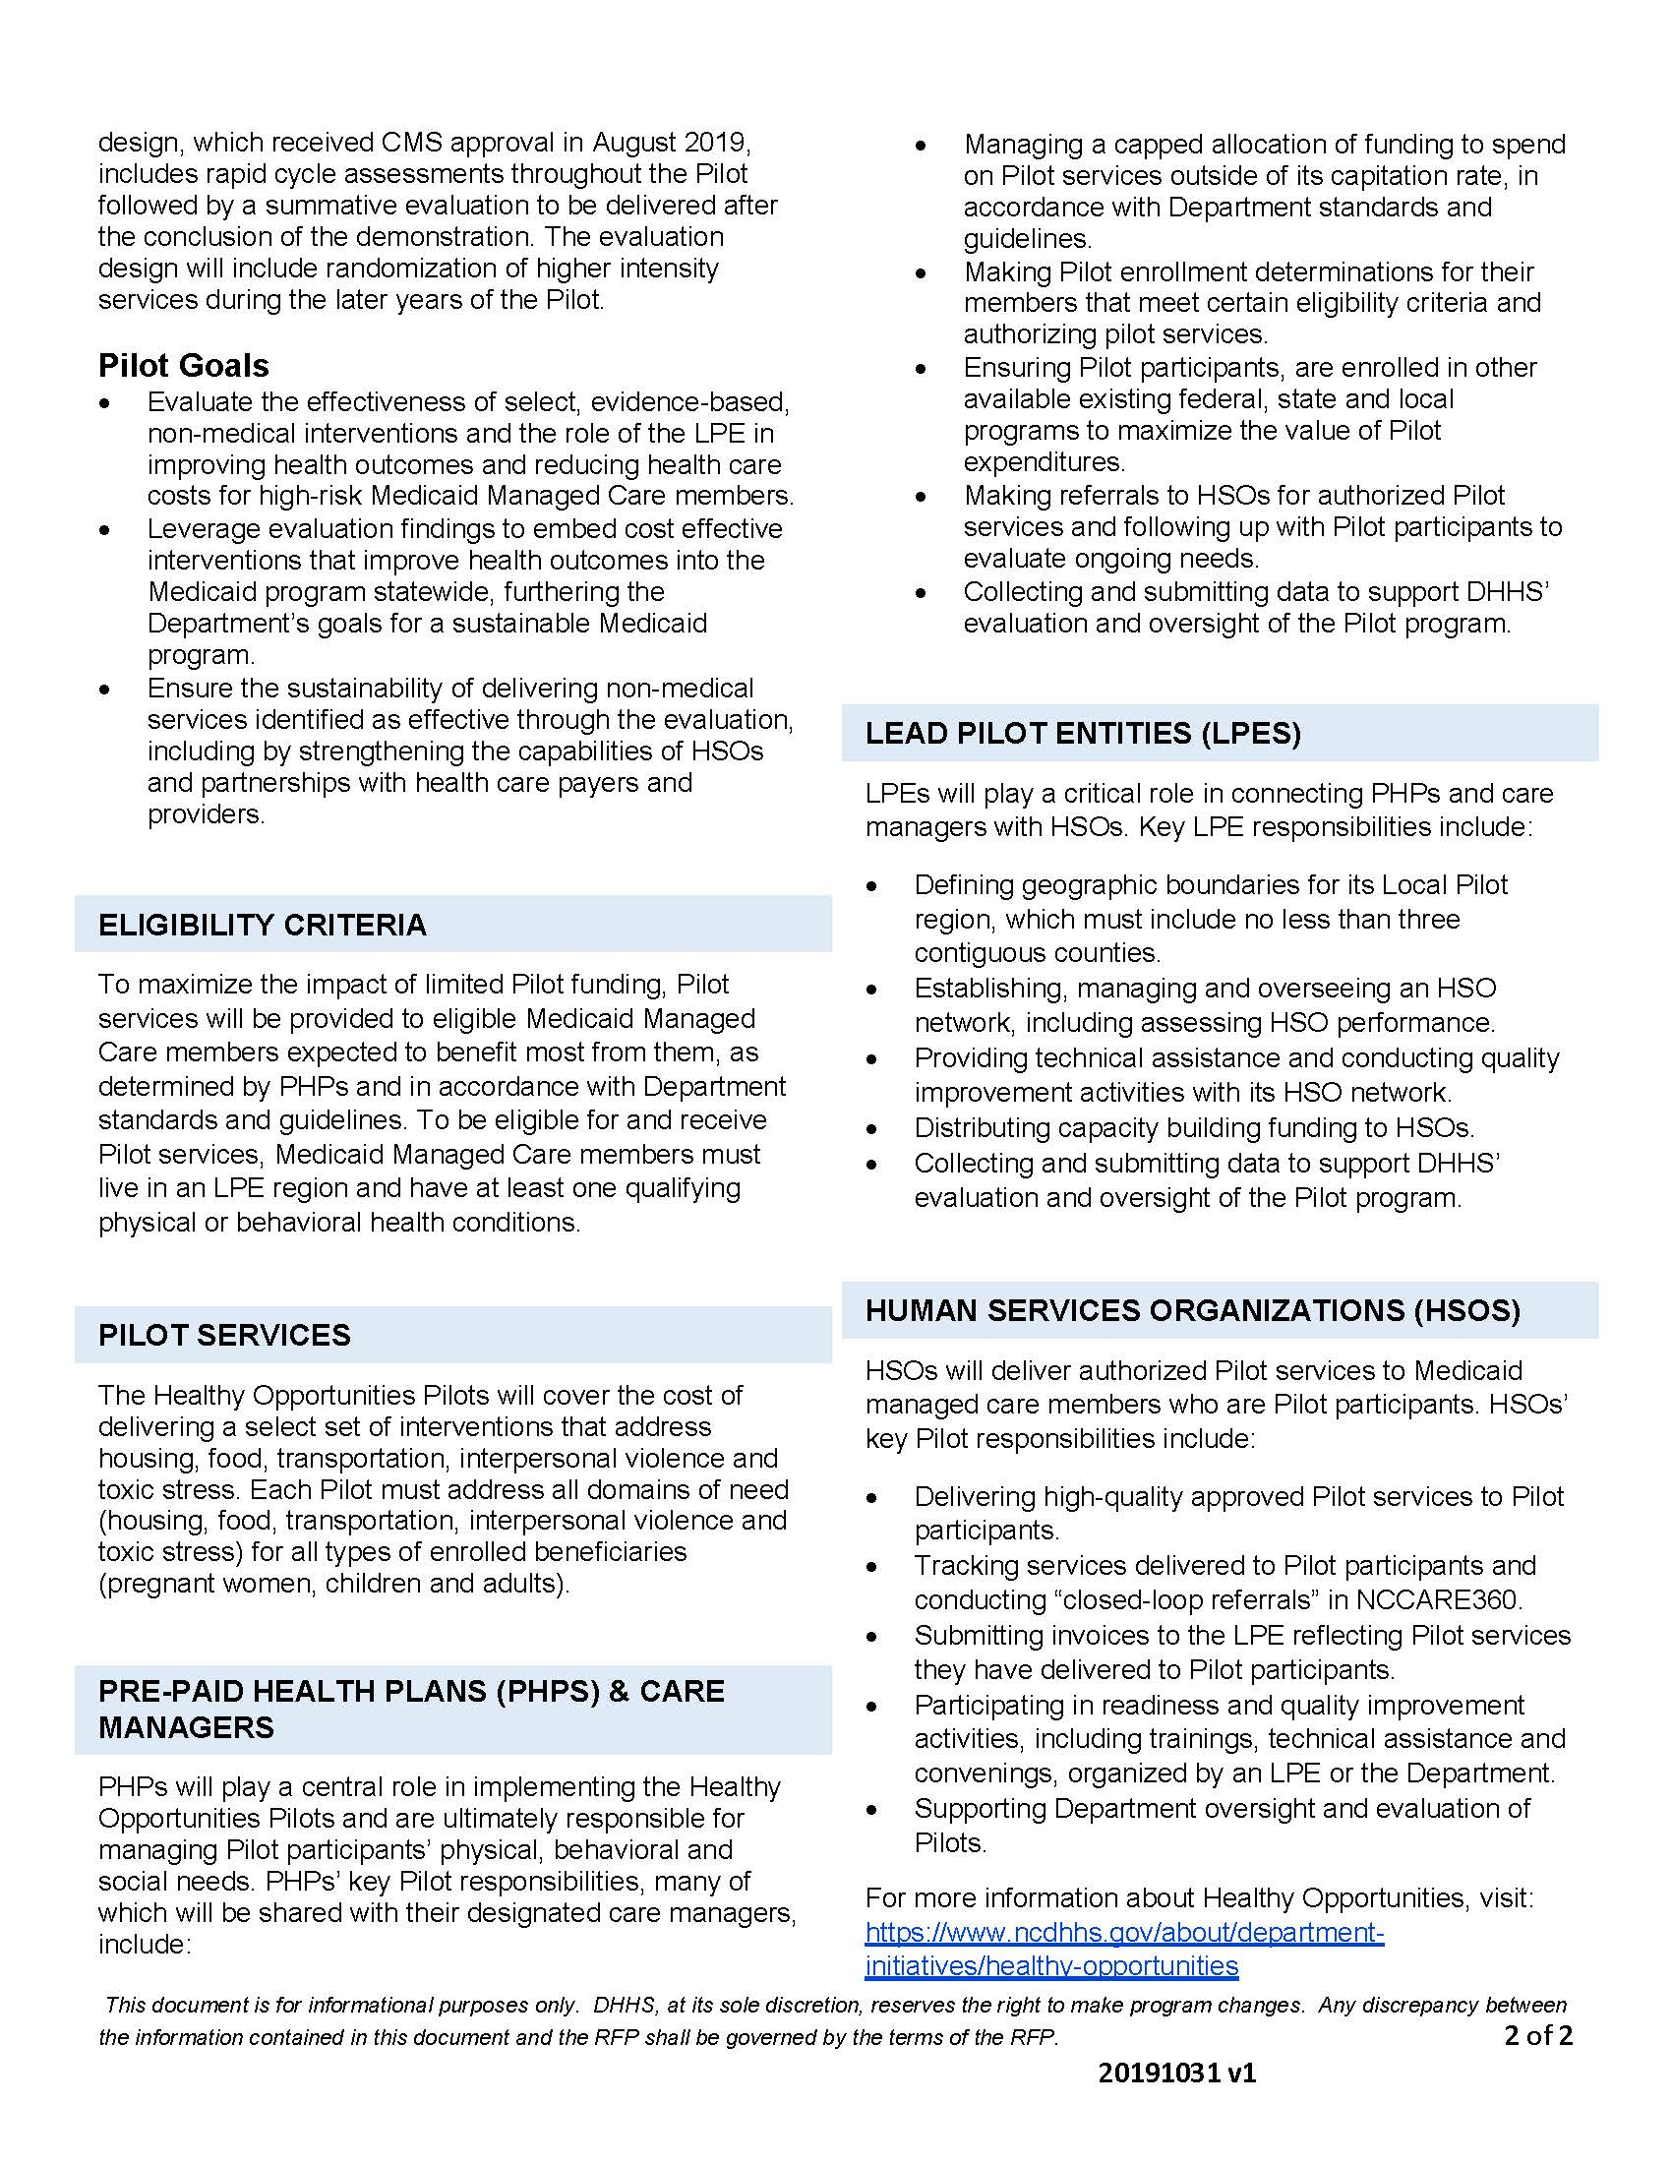

**PRESENTATION CONTINUED**

**M-E-M-O-R-A-N-D-U-M**

**ACTION ITEM #2**

TO: Executive Committee, Piedmont Triad Regional Council

FROM: Wendy Walker-Fox, Workforce Director

DATE: March 4, 2020

RE: Golden LEAF Opportunities for Work (GLOW)

The Golden LEAF Opportunities for Work (GLOW) initiative is intended to provide funding address the urgent workforce issues facing North Carolina. Because North Carolina is experiencing full employment and employers are having difficulty filling positions through traditional workforce development strategies, it is necessary to develop creative strategies to expand the pool of workers available for employment.

To help address these challenges, Golden LEAF has implemented this special workforce development initiative to address the following priorities:

* Close the skills gap by targeting working-age adults who are pursuing work but who face significant barriers to employment, are underemployed, or are experiencing long-term unemployment.
* Provide opportunity for working-age adults to obtain post-secondary credentials.
* Increase the skilled workforce.
* Increase the labor participation rate.
* Prepare working-age adults for employment in high demand fields in their community or region.

PTRC Workforce Development Department is planning a proposal to address the need for supportive services, specifically in our rural counties, by way of a transportation network. This includes existing transportation providers who could expand their service area or number of drivers in order to better serve the needs of all jobseekers, in particular those in rural areas.

This funding provides an excellent opportunity for capacity building, training and service provision.

**ACTION REQUESTED:**

Request for approval to apply for up to $500,000 in Golden LEAF Opportunities for Work (GLOW) funding in support of capacity building, training and service delivery with a focus on transportation.

**M-E-M-O-R-A-N-D-U-M**

**ACTION ITEM #3**

TO: Executive Committee, Piedmont Triad Regional Council

FROM: Jesse B. Day, Regional Planning Director

DATE: December 4, 2019

RE: G.S. 160D Zoning Enabling General Statute Changes

The Planning Department requests to enter into contract for planning services member towns and counties preparing for the G.S. 160D changes to enabling statutes for zoning/development ordinances locally. The G.S. 153A and G.S. 160A chapters for counties and cities/towns are being combined into one chapter with a number of additional required and optional changes. Several towns and counties have requested assistance in advance of the January 1, 2021 deadline.

Please let the PTRC regional planning department know if you would like to discuss any assistance that may be needed to make these changes in your area. Several small towns and some counties have requested assistance already. The School of Government has provided some great training, one in-person which was held here at PTRC in late January. The checklist of changes and different videos on the development regulations are a great guide and have been e-mailed to municipal and county staff.

**ACTION REQUESTED:**

Request for approval to enter into contract with various member jurisdictions up to $3,000 to provide these ordinance update services.

**M-E-M-O-R-A-N-D-U-M**

**ACTION ITEM #4**

TO: Executive Committee, Piedmont Triad Regional Council

FROM: Michael Blair, Community Development Director

DATE: March 4, 2020

RE: ESFRLP grant awards from the North Carolina Housing Finance Agency for 2020

The North Carolina Housing Finance Agency has awarded the PTRC, as a direct grant recipient, the ESFRLP20 grants for Guilford, Davidson and Mecklenburg (outside the city limits of Charlotte) Counties for the 2020 cycle. The PTRC Community Development Department Staff requests Executive Committee approve the acceptance of all the grants.

The PTRC Housing Department has been successful in being awarded ESFRLP grants in 14 counties currently, with 2 of the current awards being counties previously served by the PTRC in other grant cycles. Mecklenburg outside of the Charlotte city limits is a new county with low production from its previous grant recipient and the NCHFA has encouraged the PTRC to apply, as there has been little interest from other entities applying for this grant.

The grants are set up on a loan pool system, so once the initial five units are completed, the PTRC can continue to apply for funding for homes until the funding supply is depleted. As an example, in the current grant cycle for Randolph County, PTRC committed to completing five units for $175,000 and will close out the grant cycle with seventeen units completed totaling $584,025.00 in home repairs for residents of the county.

**ACTION REQUESTED**: The PTRC Community Development Department is requesting approval from the board to accept the awarded NCHFA ESFRLP20 grants.

**Meeting Dates 2020**

**1398 Carrollton Crossing Drive**

**Kernersville, NC 27284**

**12:00 noon**

|  |  |
| --- | --- |
| PTRC Executive Committee  1st Wednesday | PTRC Board of Delegates  3rd Wednesday |
| ~~January - none~~ | **~~January - none~~** |
| ~~February 5, 2020~~ | **~~February 19, 2020 cancelled~~** |
| March 4, 2020 | **March - none** |
| April 1, 2020 | **April 15, 2020** |
| May 6, 2020 | **May - none** |
| June 3, 2020 | **June 17, 2020** |
| July - none | **July - none** |
| August 5, 2020 | **August 19, 2020** |
| September 2, 2020 | **September - none** |
| October 7, 2020 | **October 21, 2020** |
| November 4, 2020 | **November - none** |
| December 2, 2020 | **December 16, 2020** |

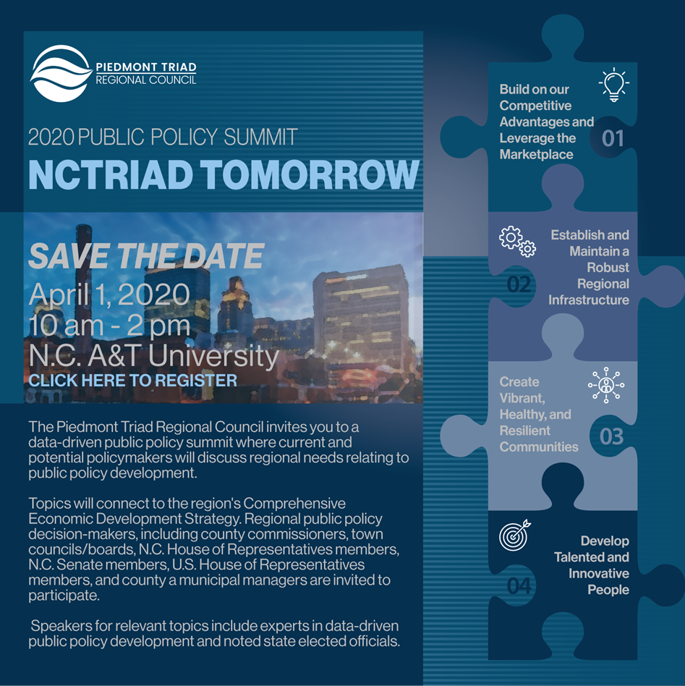

**INFORMATIONAL ITEM**